**GENC CAPSTONE-**

**FINAL PROJECT**

**PREPARED BY: -**

**SANCHITA DAS**

**EMPLOYEE ID: 2319855**

**COHORT CODE: CSDAIA24AZ002**

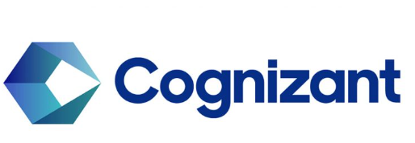

**Problem Statement:**

Load data in staging raw layer as zip file & processed or clean data that has been arrived in last 24 hrs from source & load into ADLS refined container in parquet file as delta table.

**Requirements 1 - Data Preparation (use ADF):**

**1. Loading Raw Data:**

* The source data will be loaded into the raw container in ADLS in zip file format.

**2. Unzipping and Loading Data into Staging:**

* Unzip the files that have arrived in the last 24 hours from the source.
* Load the unzipped files into the ADLS refine container in the path: refine/<participant_name>/Unzippeddata/file.

**3. Processing and Loading Clean Data:**

* Process or clean the data from the unzipped files using Azure Databricks (ADB).
* Load the processed or clean data under the refined container using either Azure Databricks or Azure Data Factory (ADF) in the form of parquet files.

**STEPS TO BE FOLLOWED:-**

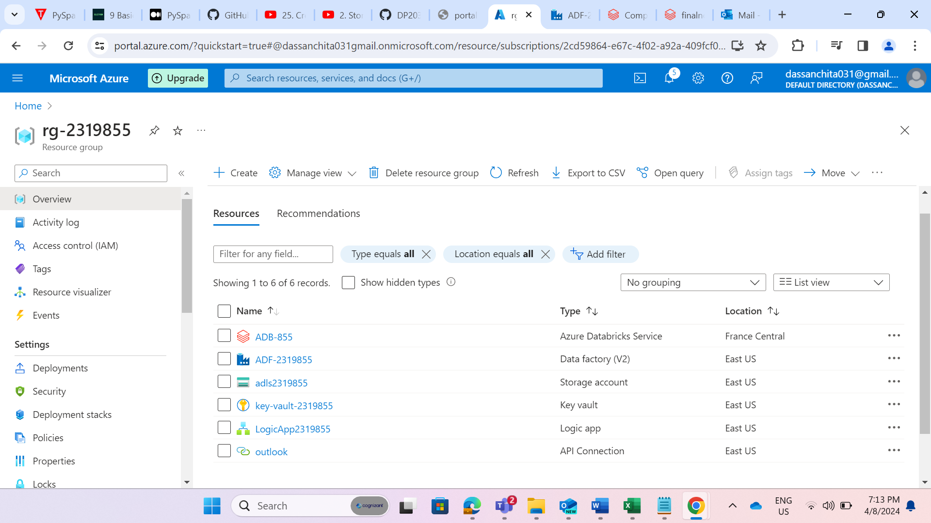

STEP 1: These are the essential resources that I have created for my project.

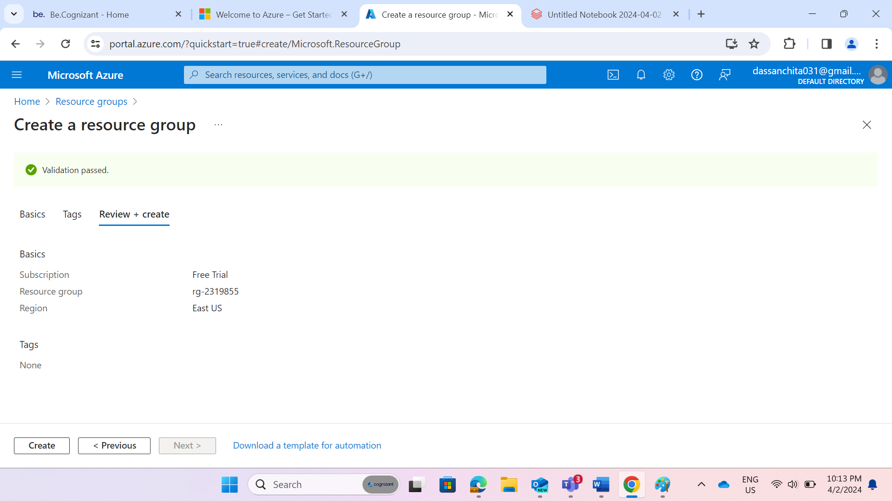

STEP 2: Created a Resource Group named as “rg-2319855.”

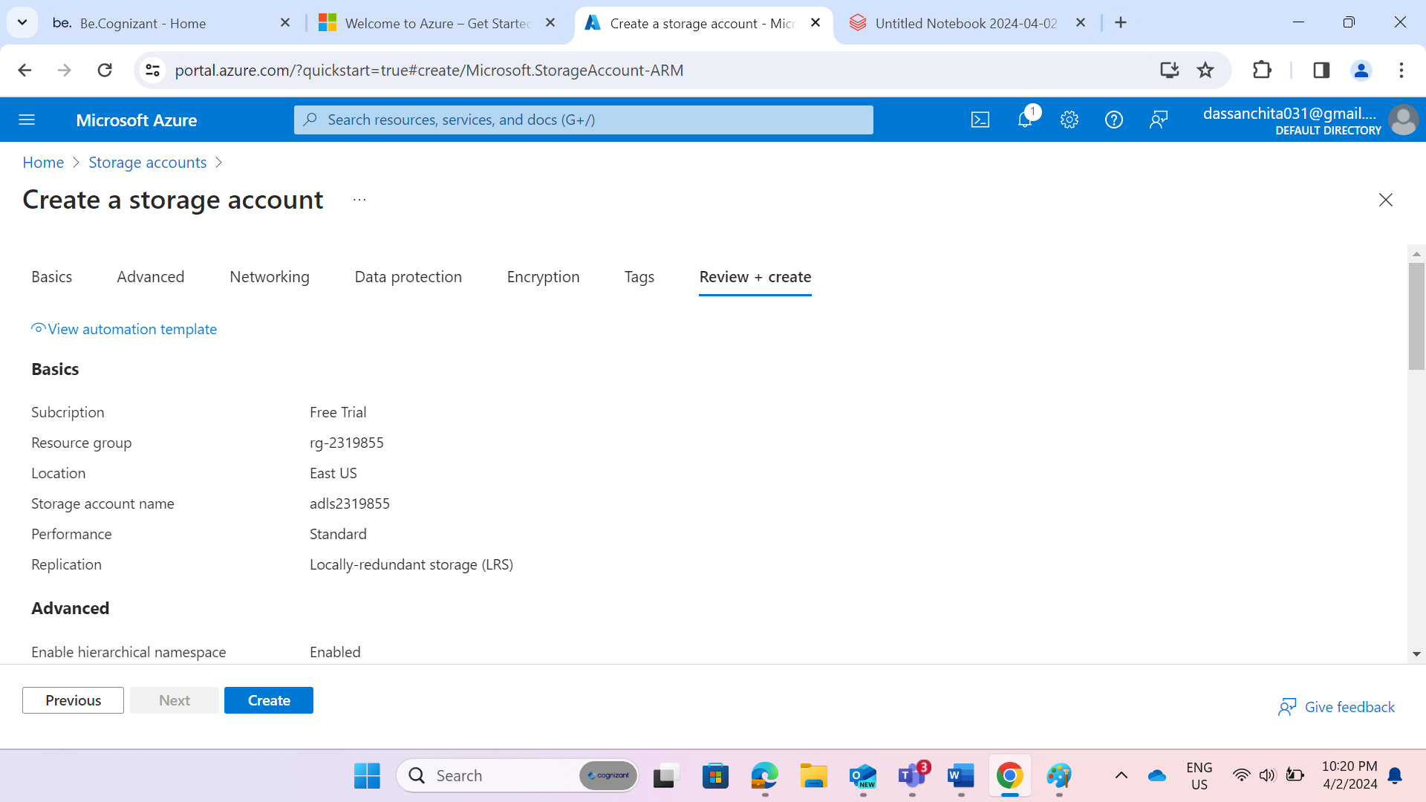

STEP 3: Created an Azure Data Lake Storage Account named as “adls2319855.”

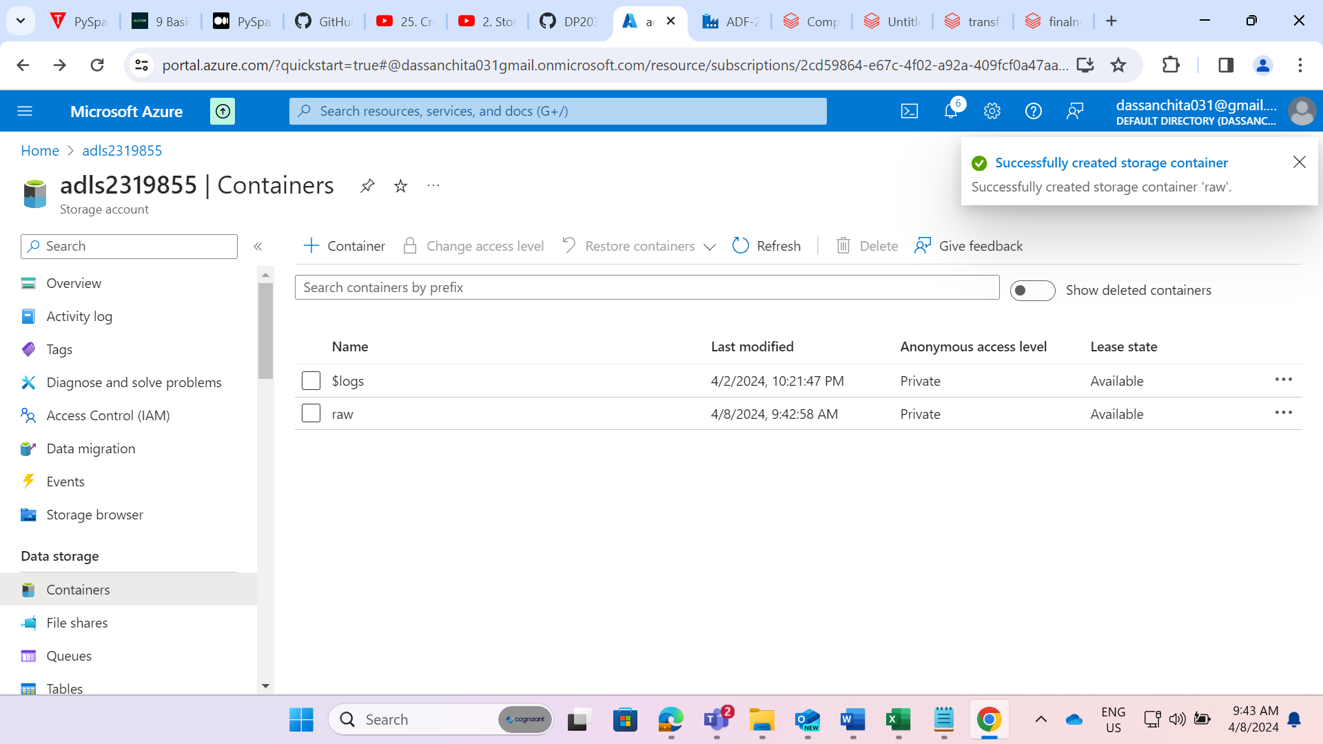

STEP 4: Created a container named “raw” within the storage account and uploaded the zip file.

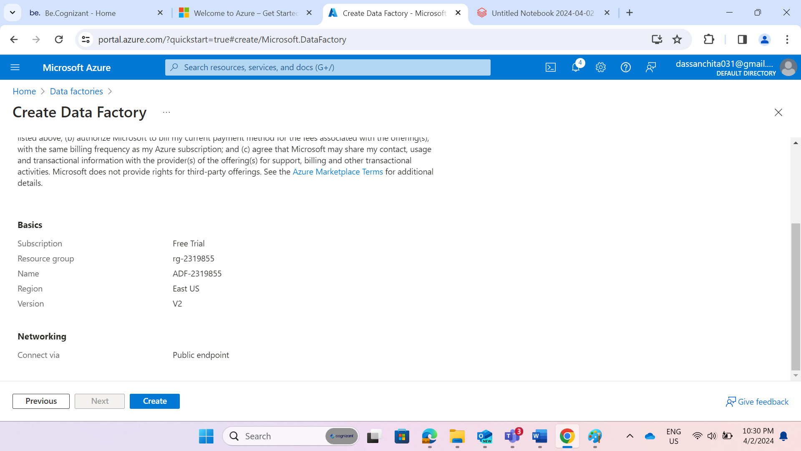

STEP 5: Created an Azure data Factory named as “ADF-2319855” under the same resource group.

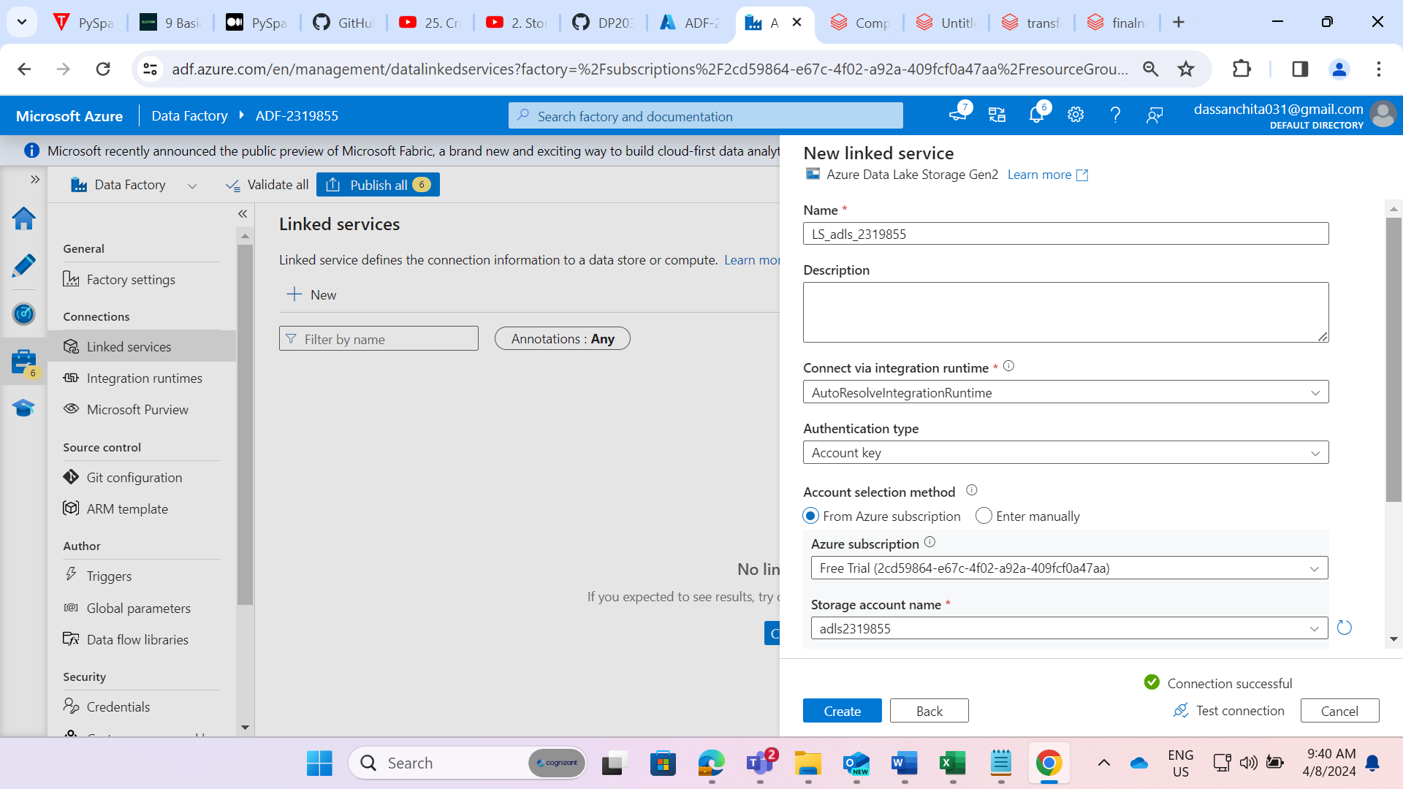

STEP 6: Created a linked service named as “LS_adls_2319855”.

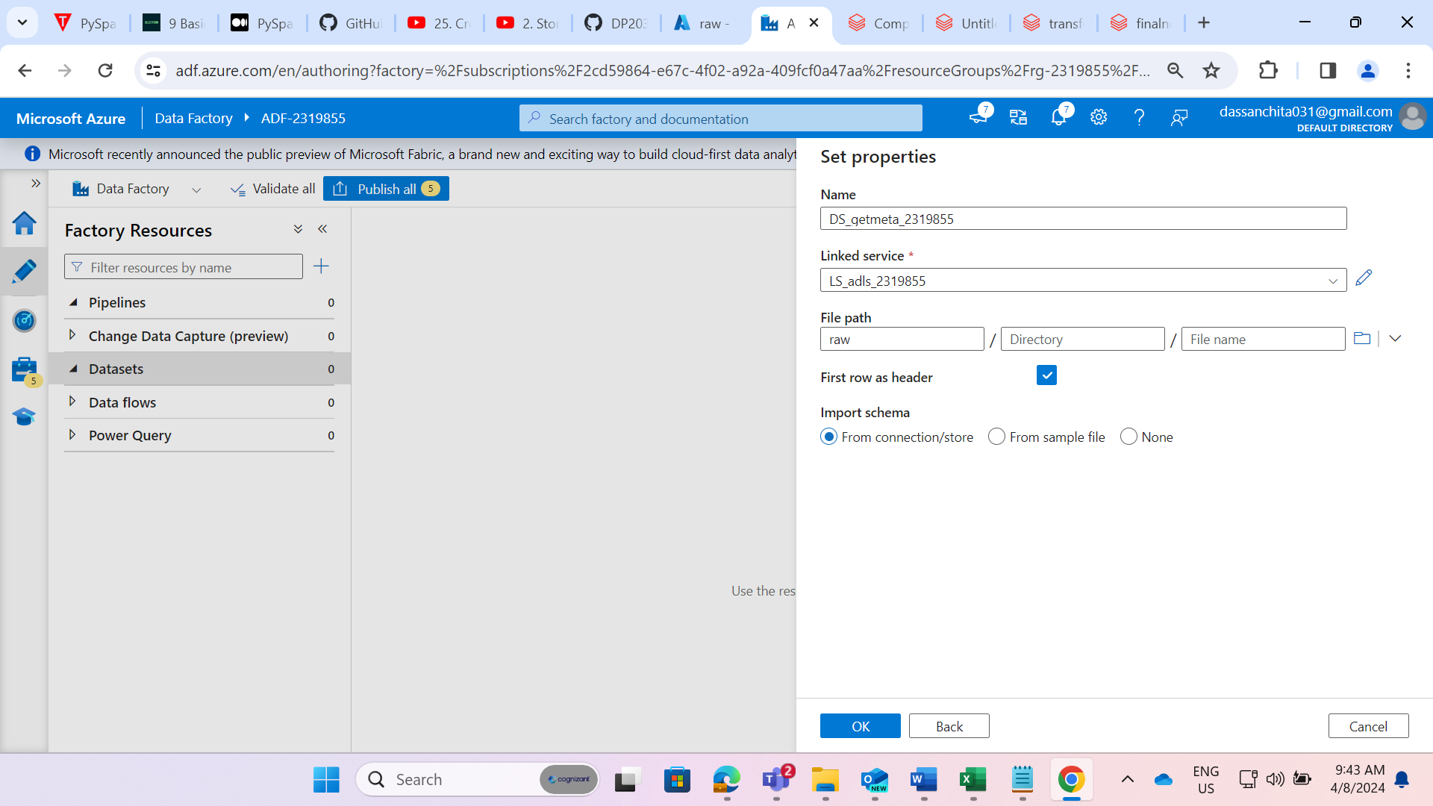

STEP 7: Created a dataset named as “DS_getmeta_2319855”

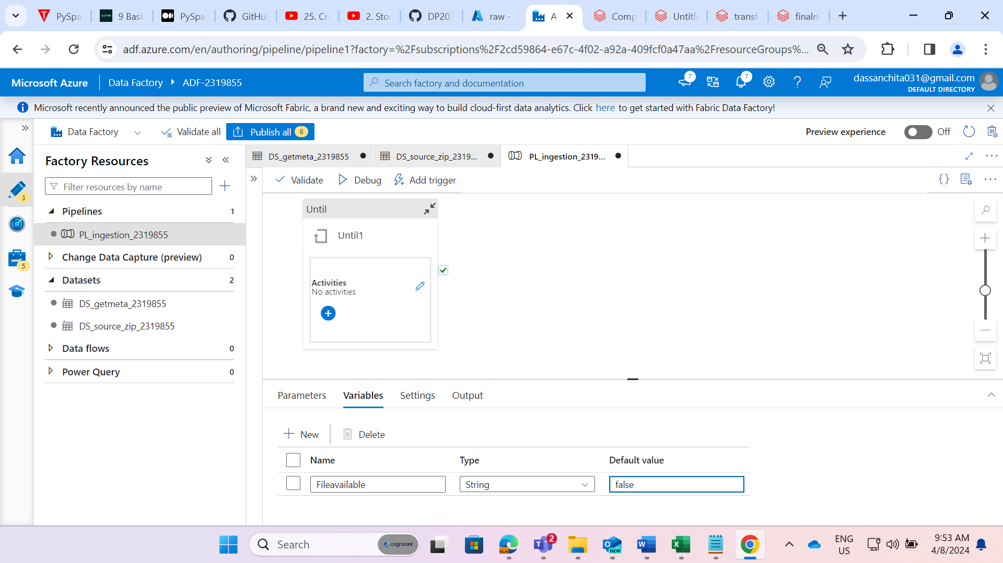

STEP 8: Created a pipeline named as “PL_ingestion_2319855” and created a variable named as “Fileavailable” in a pipeline level.

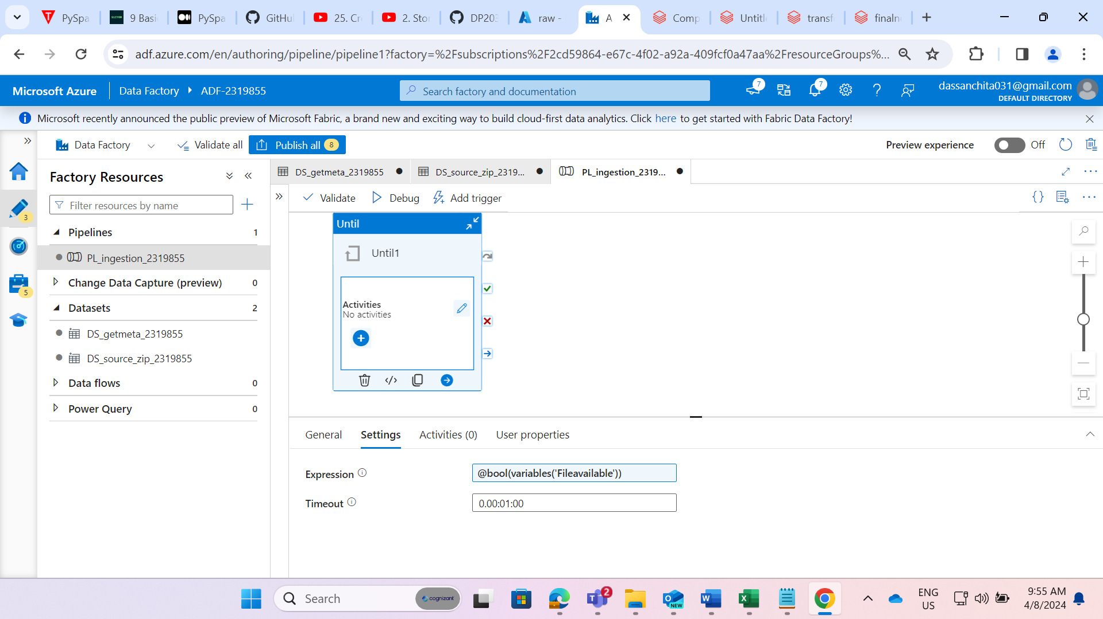

STEP 9: Given the expression as “@bool(variables(“Fileavailabe”))” and timeout as 1 min in until activity.

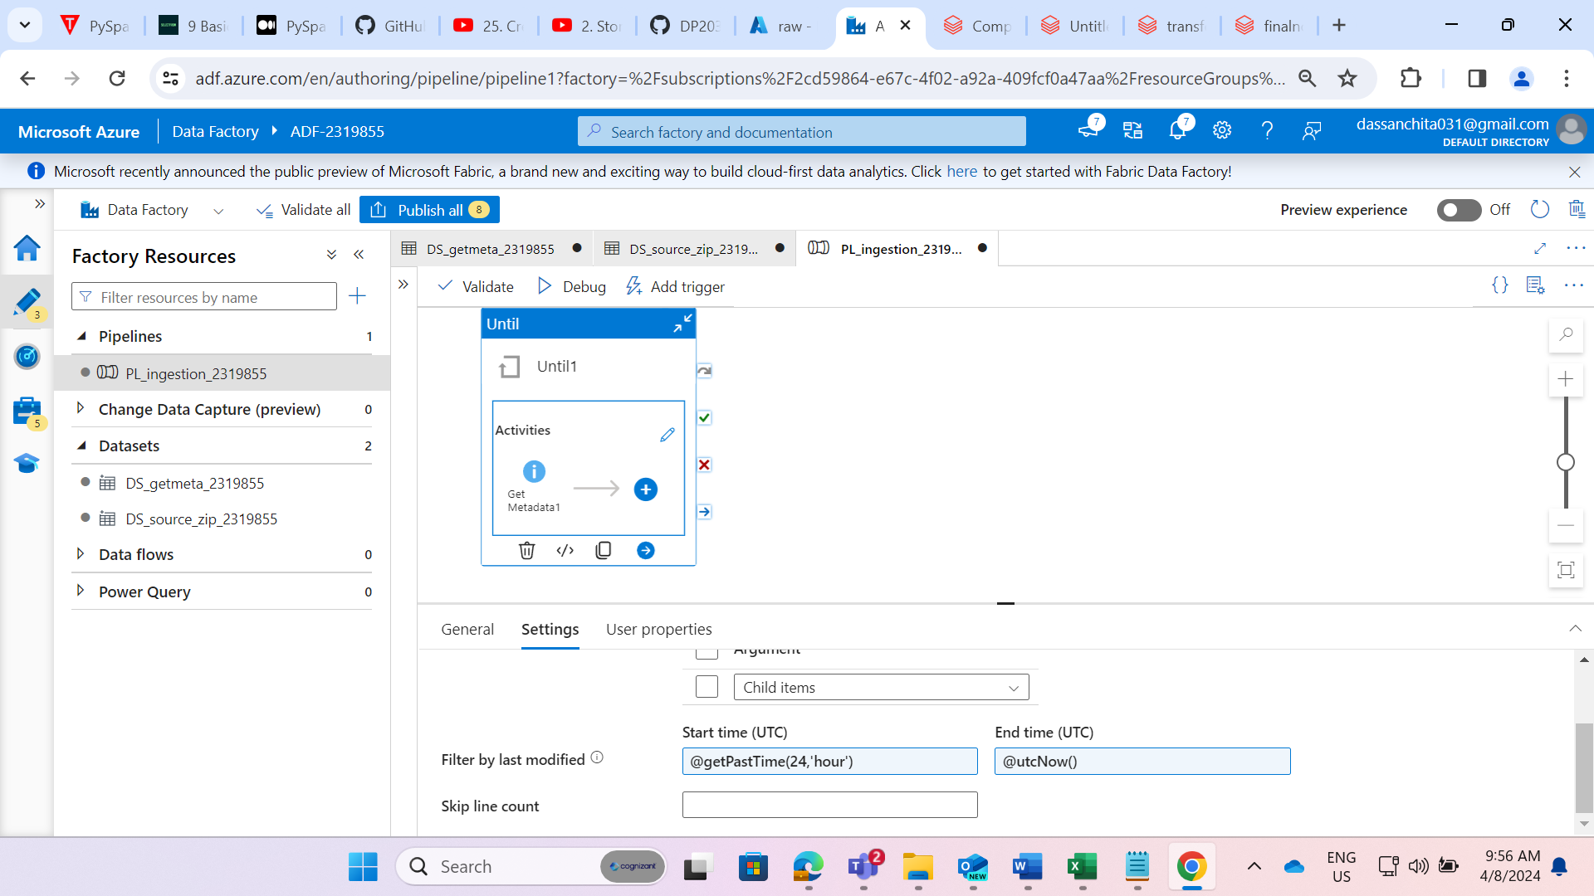

STEP 10: Added GetMetadata activity inside the Until activity and the field list that we want to deal with in our requirement.

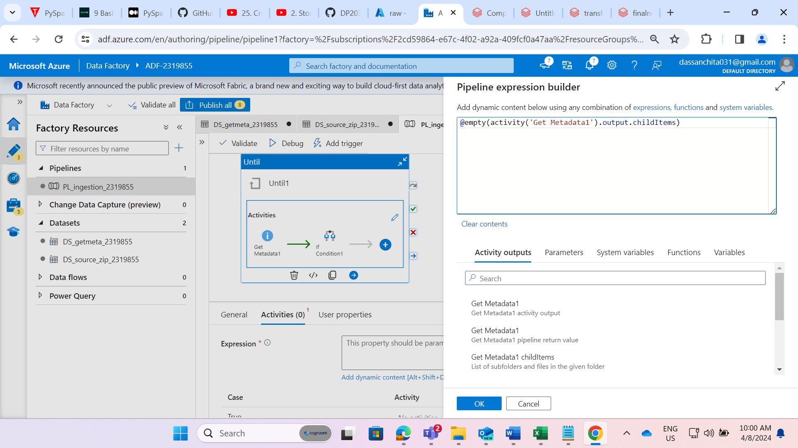

STEP 11: Added “if condition” activity and output of metadata activity is given to it.

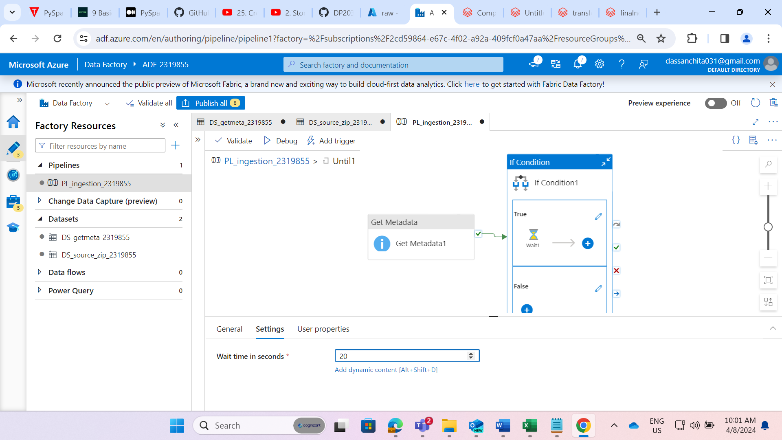

STEP 12: In case of true, I have added wait activity.

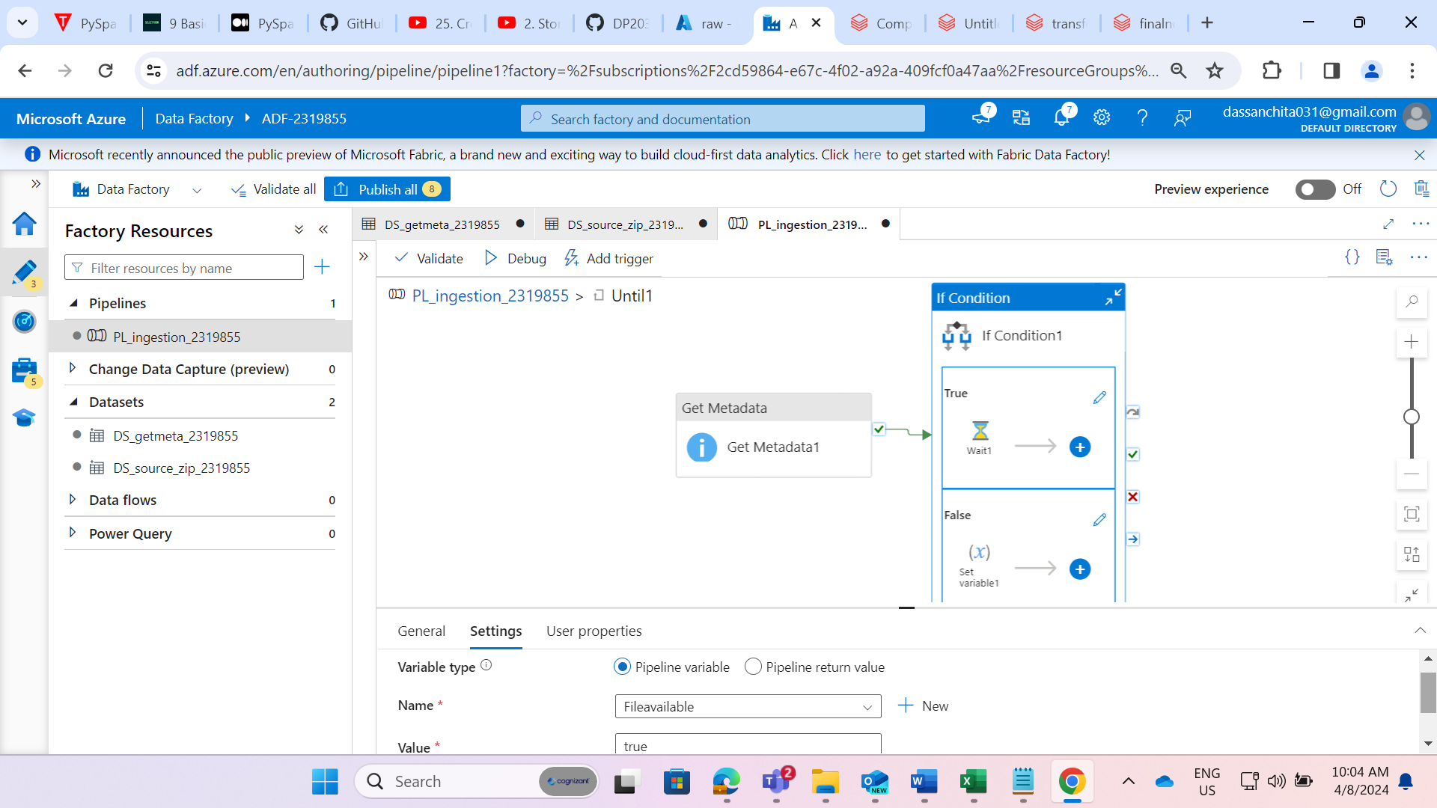

STEP 13: In case of false, I have added set variable activity.

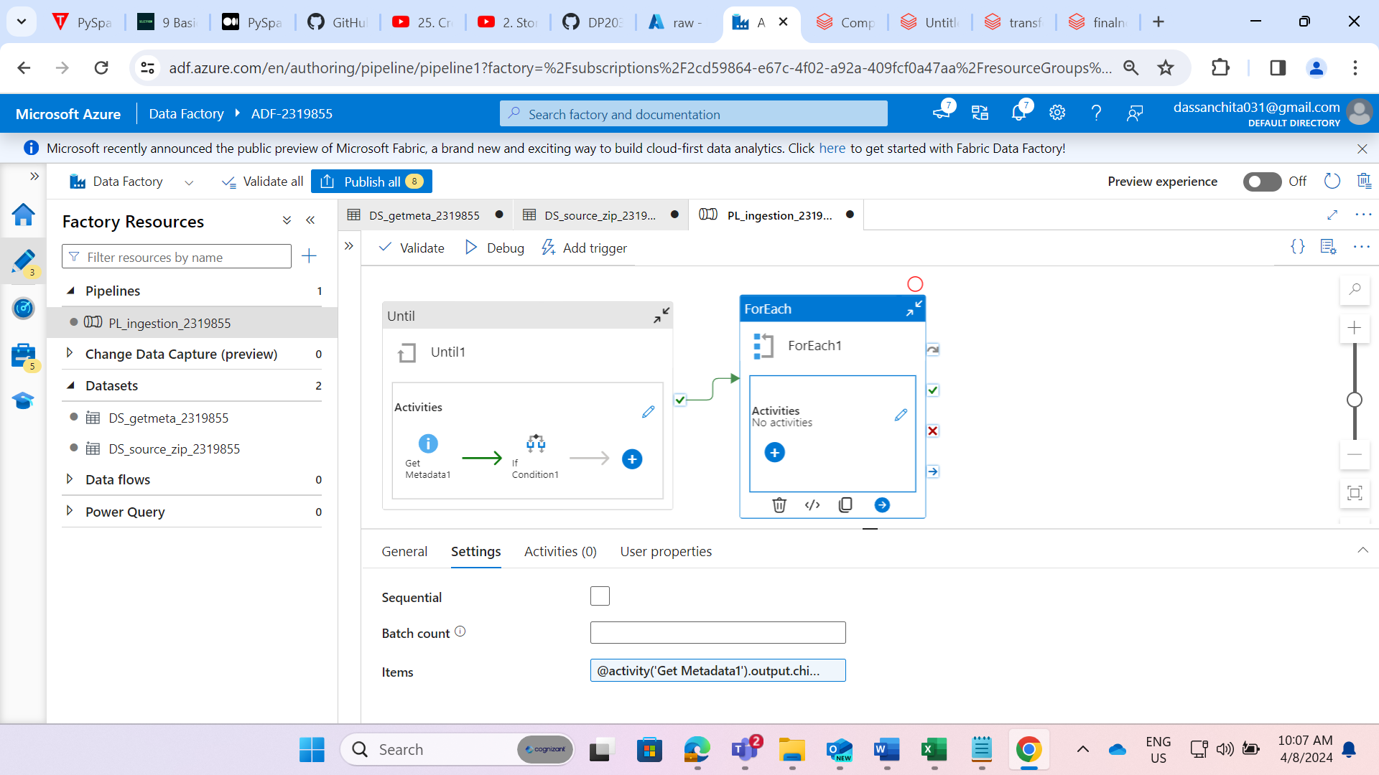

STEP 14: Now, I have added foreach activity and given the output of metadata activity to it.

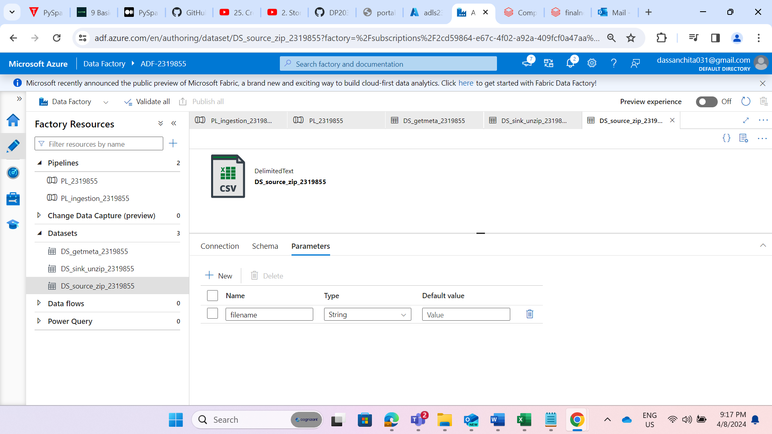

STEP 15: Created the source dataset named as “DS_source_zip_2319855” for copy activity inside the foreach activity and created the parameter to access the file dynamically.

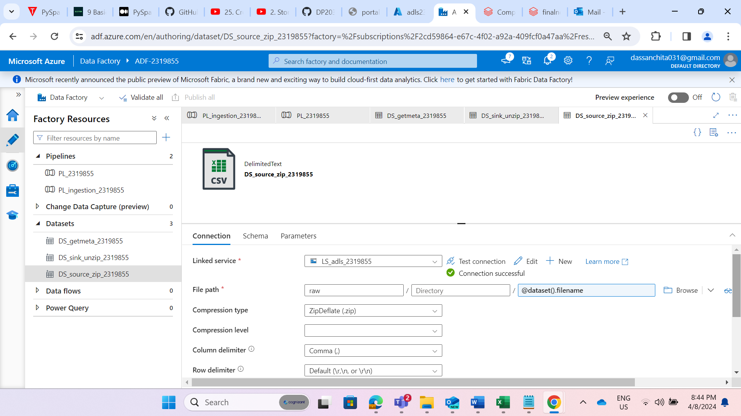

STEP 16: Dynamically defined the file path.

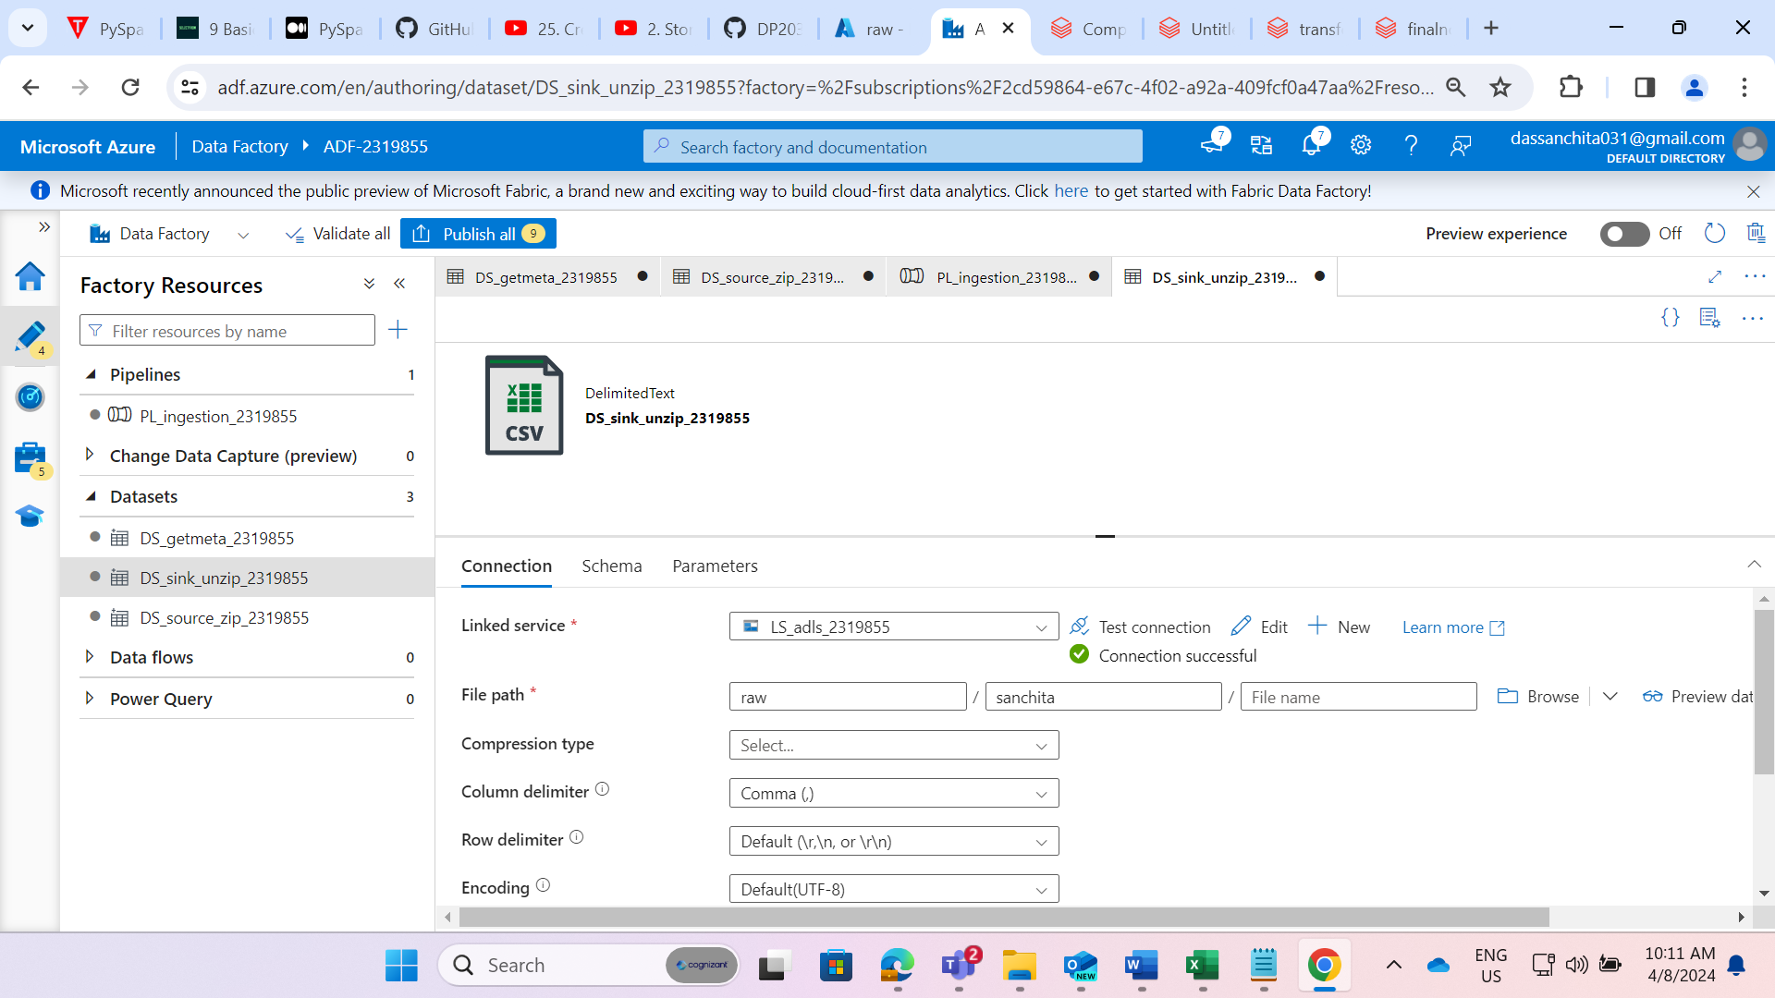

STEP 17: Created a sink dataset named as a “DS_sink_unzip_2319855” for copy activity inside foreach activity and pointed the path of container to where the files should be unzipped

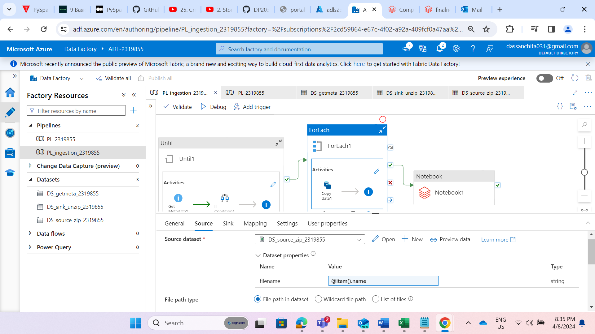

STEP 18: Now added the copy activity inside the foreach activity to unzip the files.

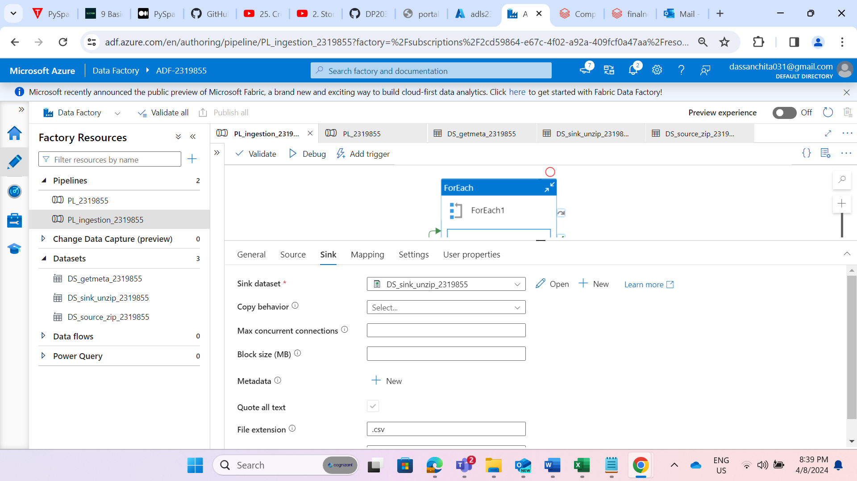

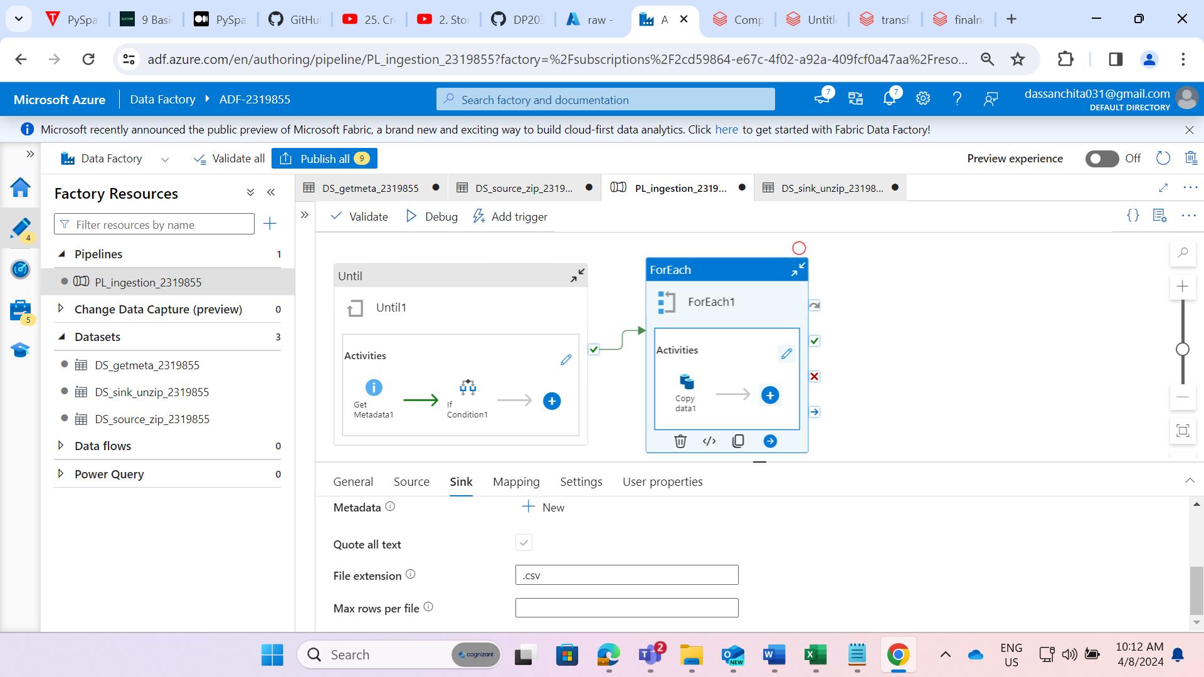

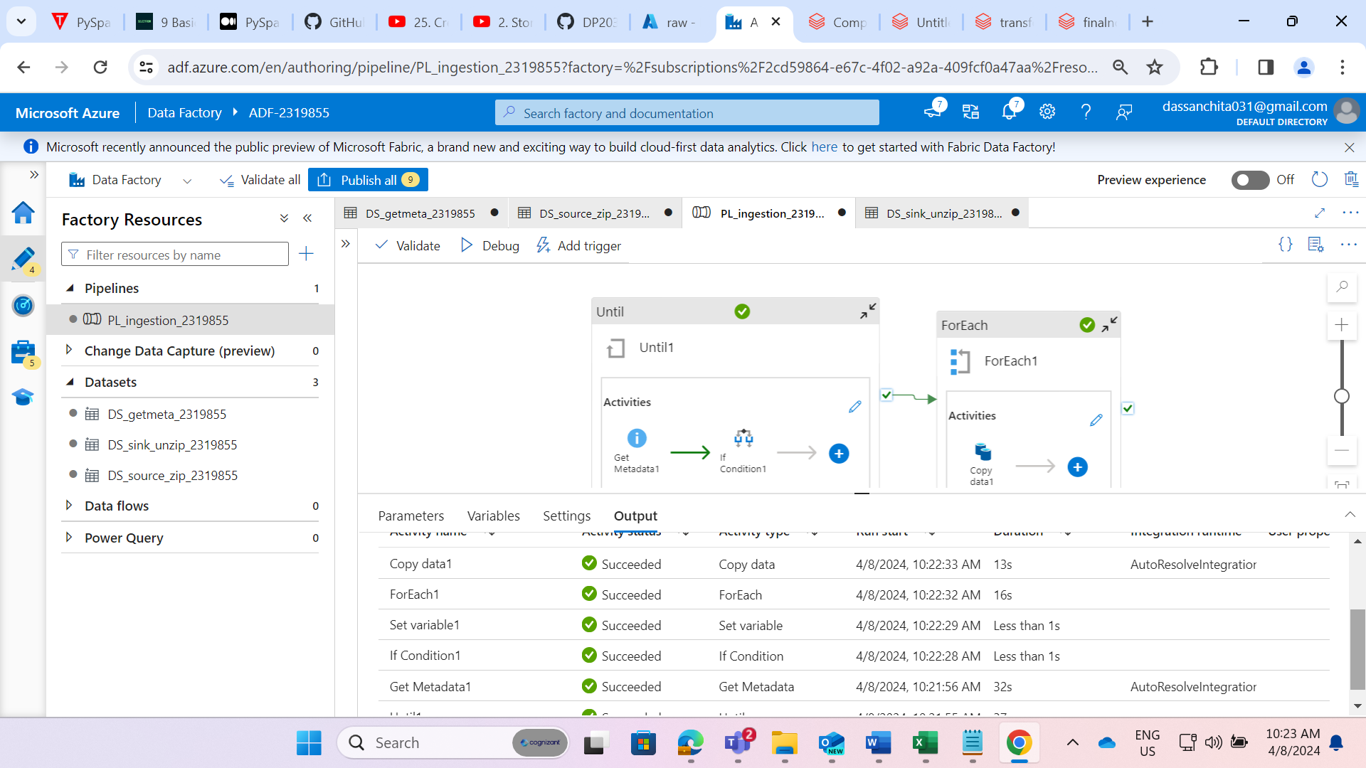

STEP 19: Now we have successfully unzipped the file with help of ADF.

**Requirements 2 - Data Transformation (use ADB):**

**1. Accessing Data Lake using Secret Keys:**

* Access the data lake using secret keys by creating secrets in Key Vault.

**2. The following are the transformations we have to perform:**

* If date is NULL or blank, give default date as ‘2020-11-28’. Format of date column should be YYYY-MM-DD.
* Remove ‘_’ from column header.
* For timestamp column cast in timestamp & rename with DateTime.
* Put correct date type of each column.
* Combine FirstName, MiddleName & LastName as FullName.
* Add new column InsertDate with insertion date.

**3. Creating Delta Tables:**

* Created delta tables in Azure Databricks and load data in the form of parquet files into the refined data lake container.

**4. Visualization and Analysis:**

* Created visualizations on the cleaned data and generate graphs to understand the data easily.

**Setup Email Configuration:**

* Configure email notifications for pipeline failure and success.
* The email should contain pipeline name, run ID, and failure/success message.

**STEPS TO BE FOLLOWED:**

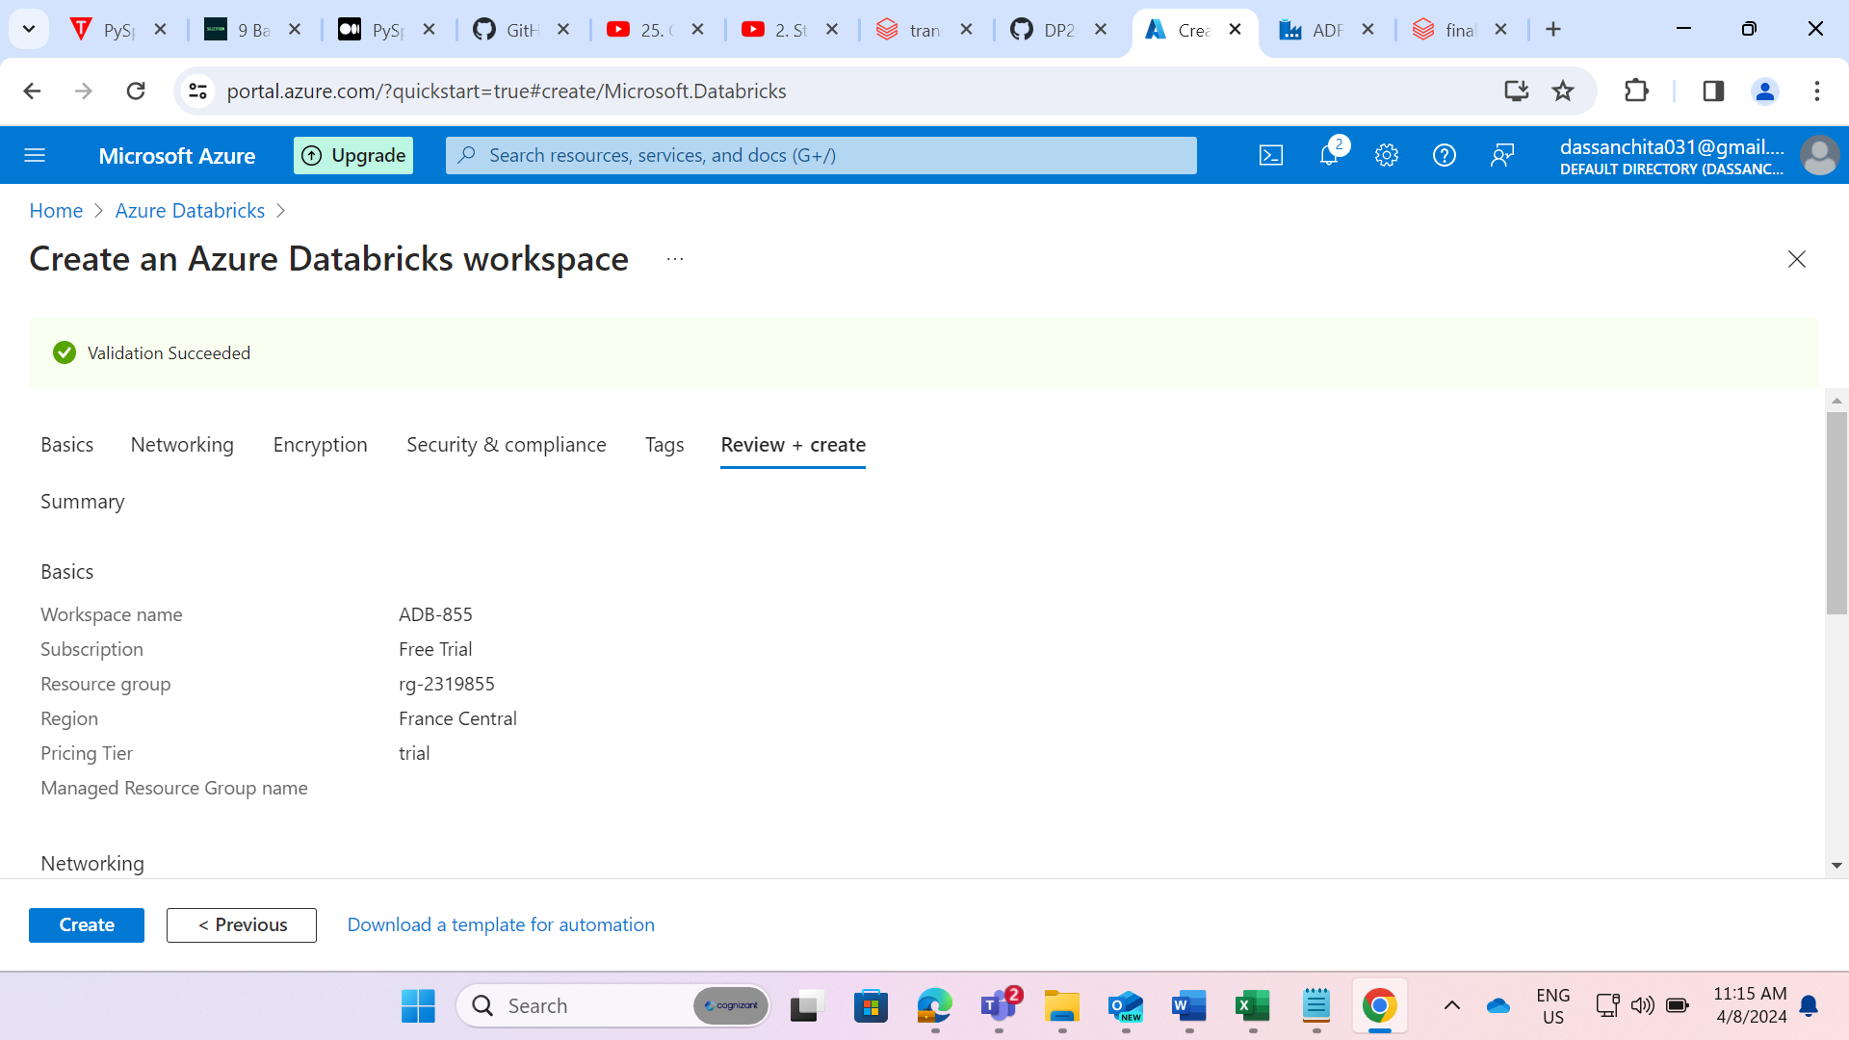

STEP 20: Created an Azure Databricks workspace named as a “ADB-855”

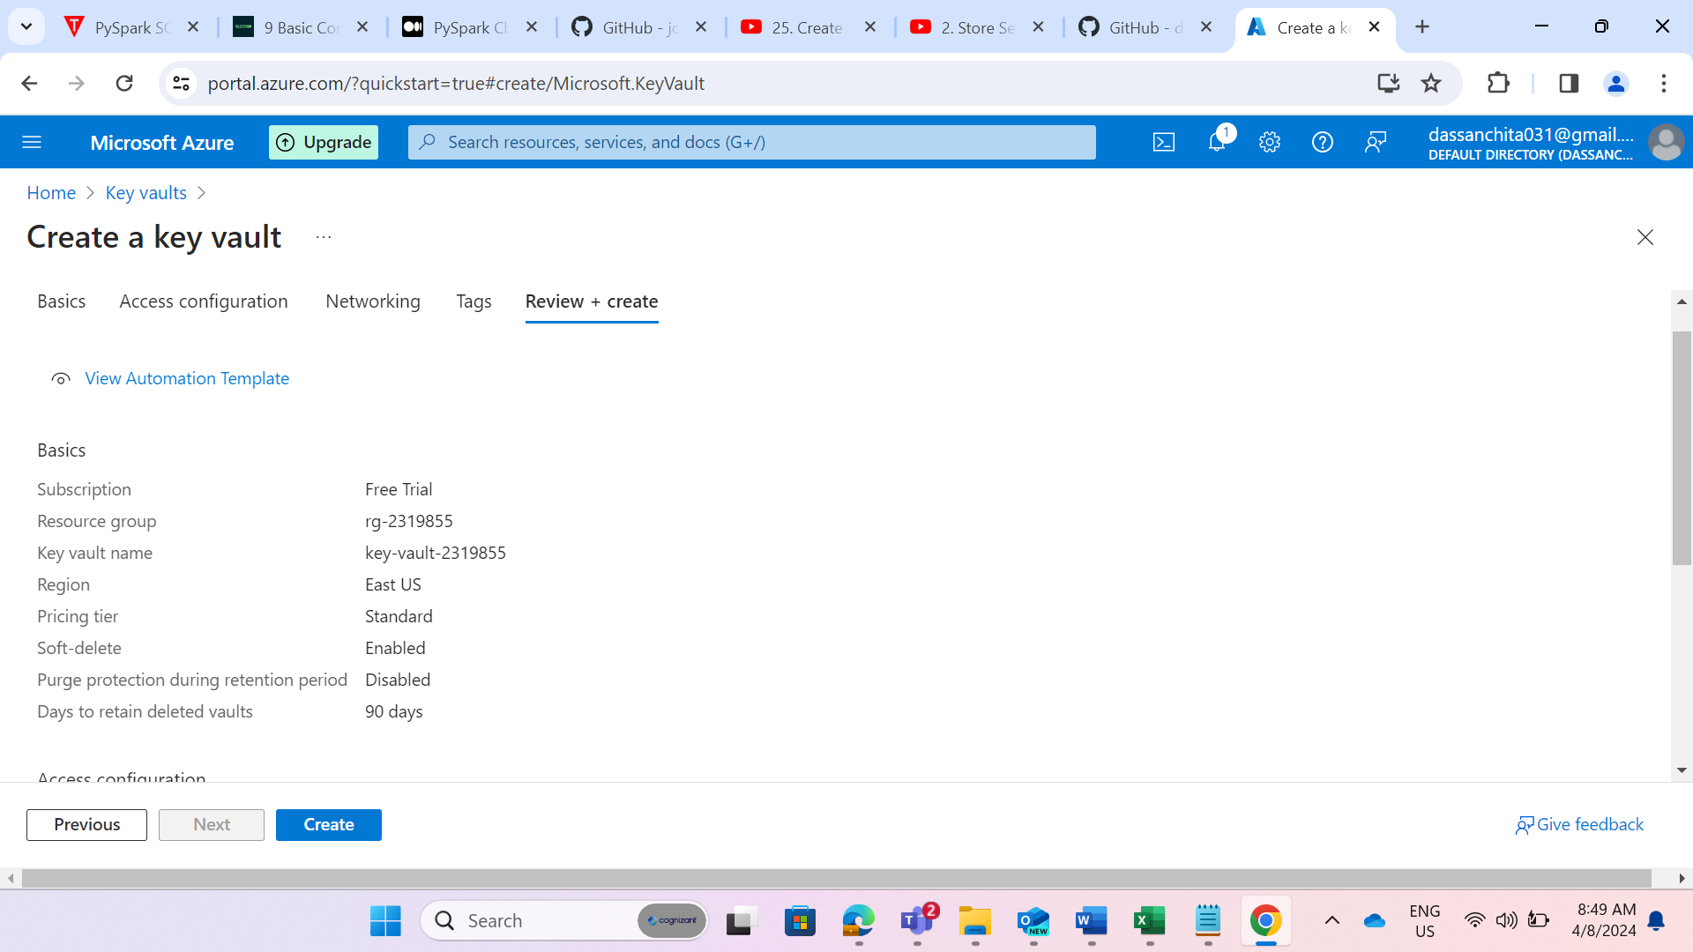

STEP 21: Created a key vault to authenticate the Azure datalake with Azure databricks.

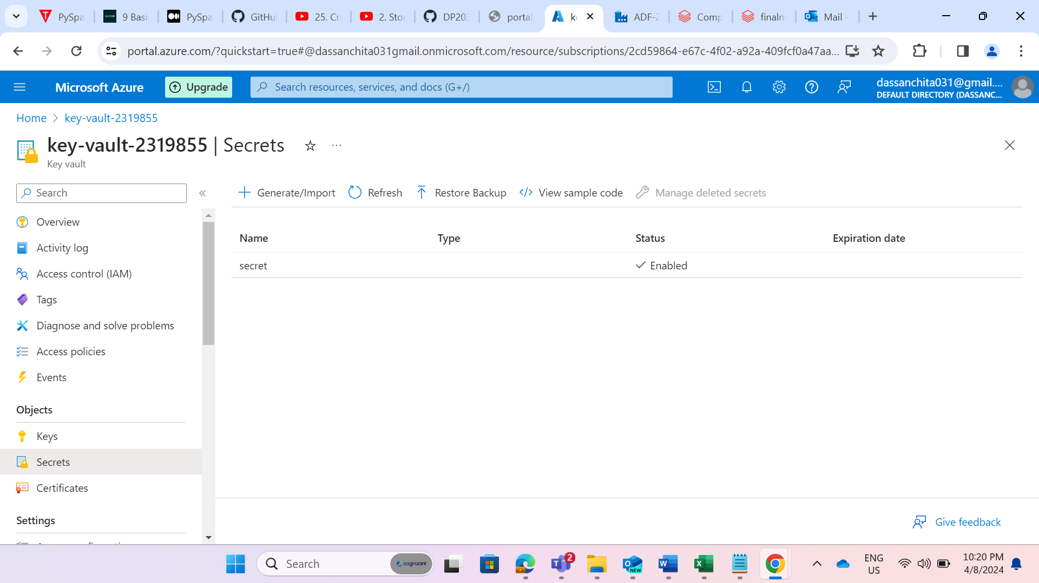

STEP 22: Created a secret named as “secret”. While creating the secret we have given the secret value as the access key of storage account.

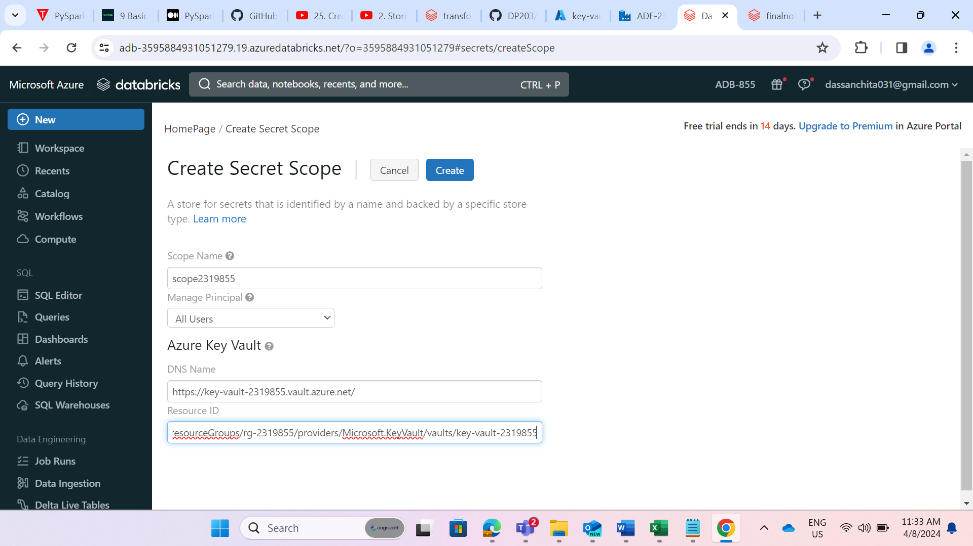

STEP 23: Created the scope named as “scope2319855” in Azure databricks and given the azure key vault details.

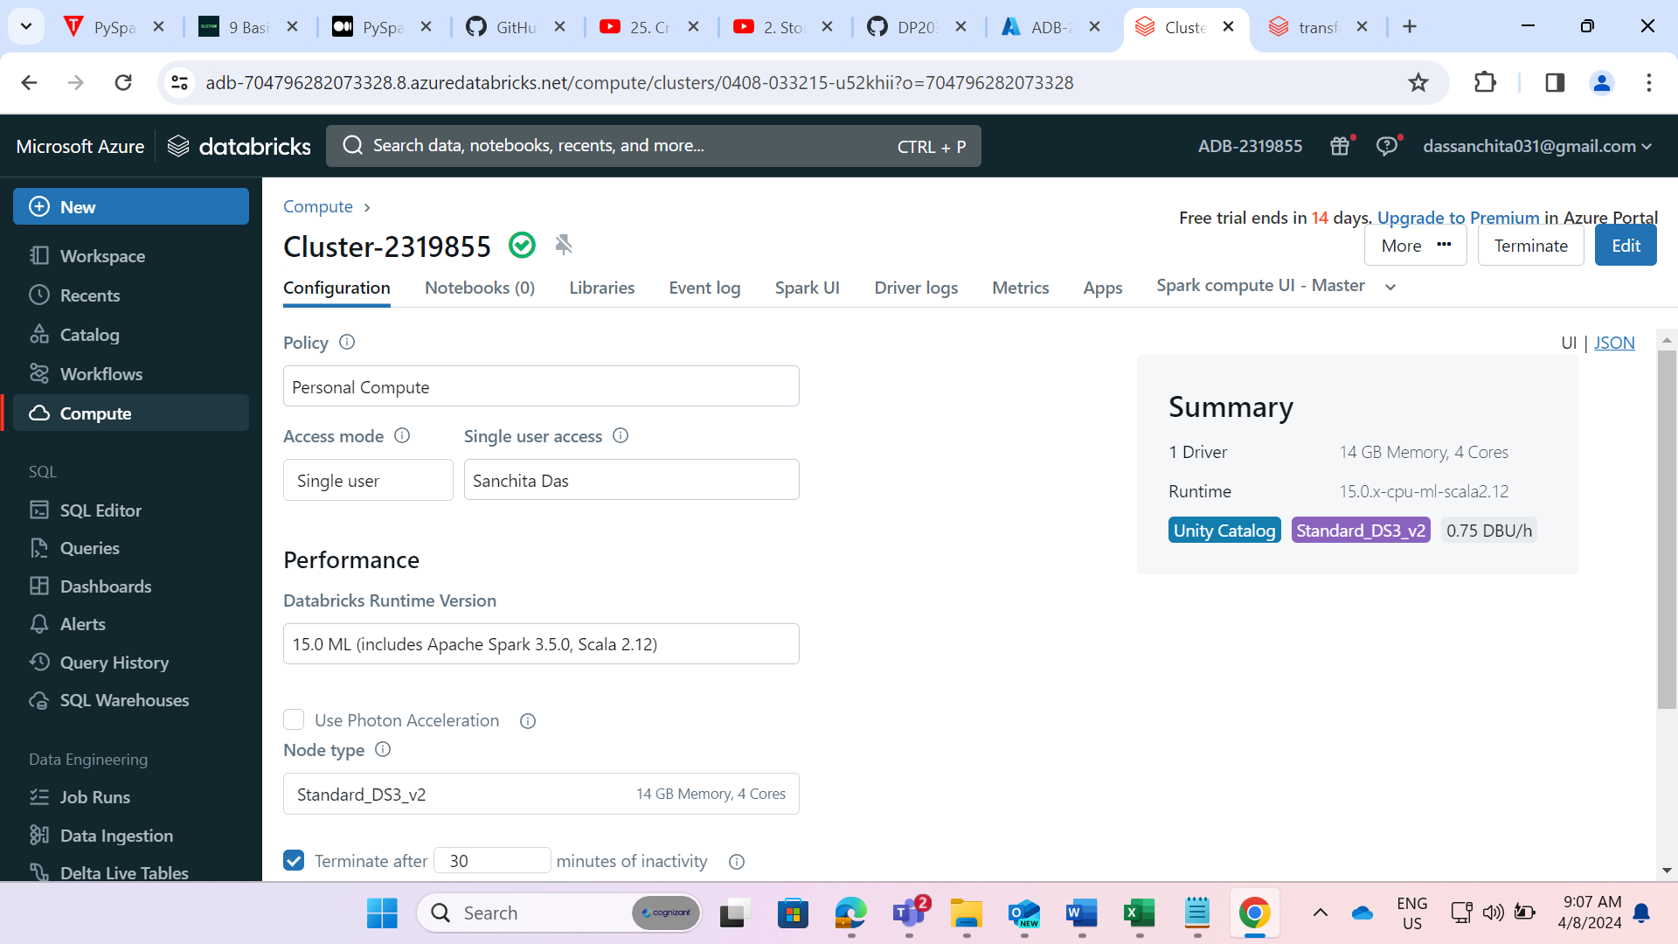

STEP 24: Created a cluster named as “Cluster-2319855”.

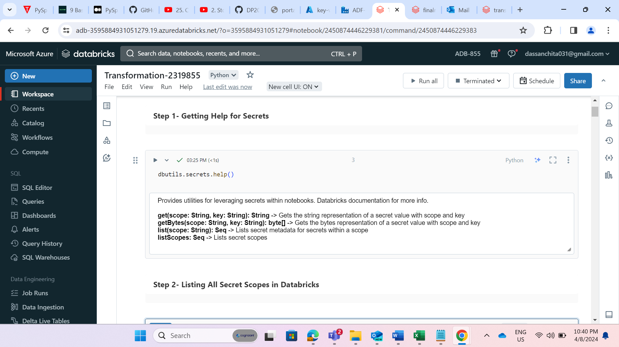

STEP 25: Created a notebook named as “Transformation-2319855”

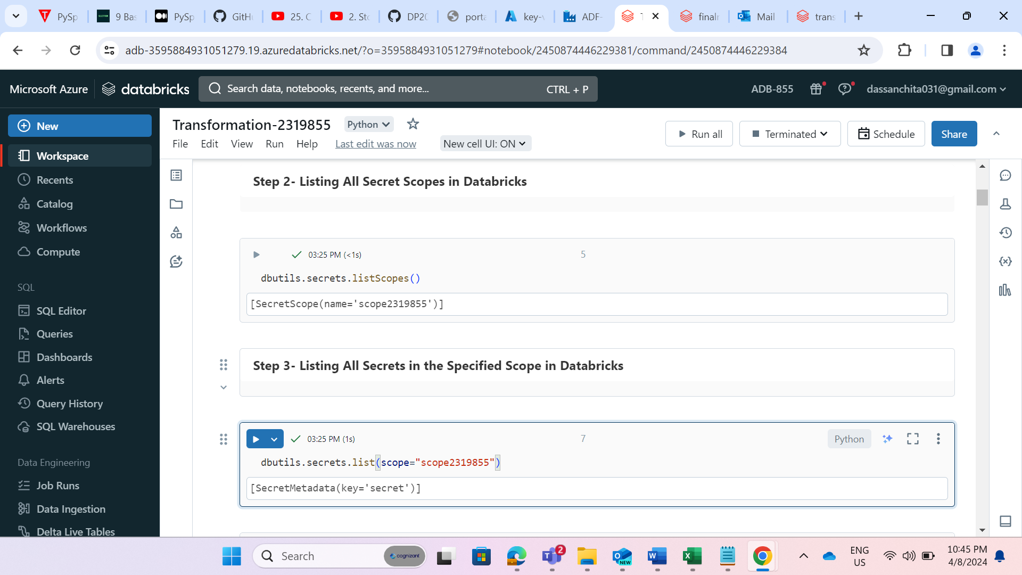

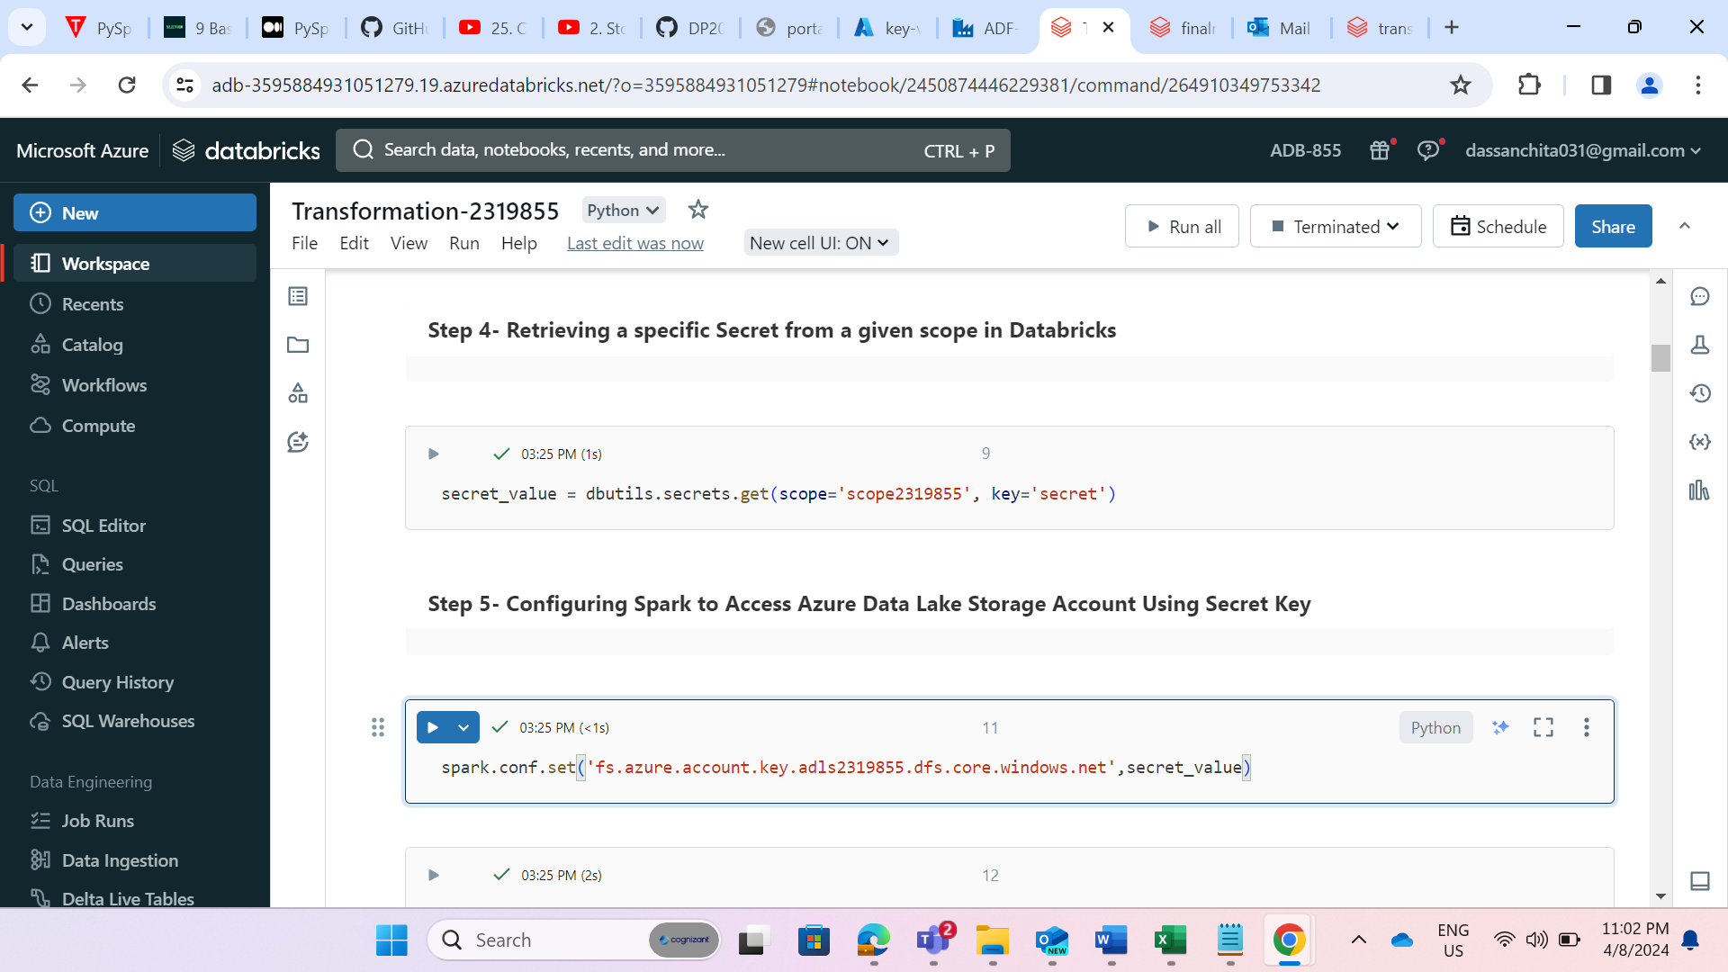

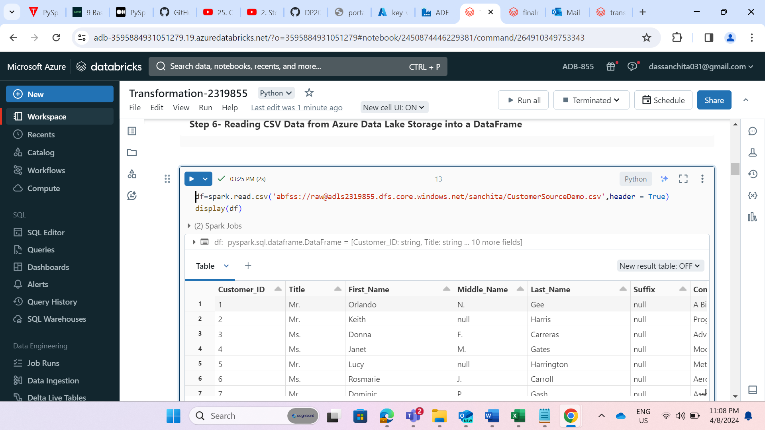

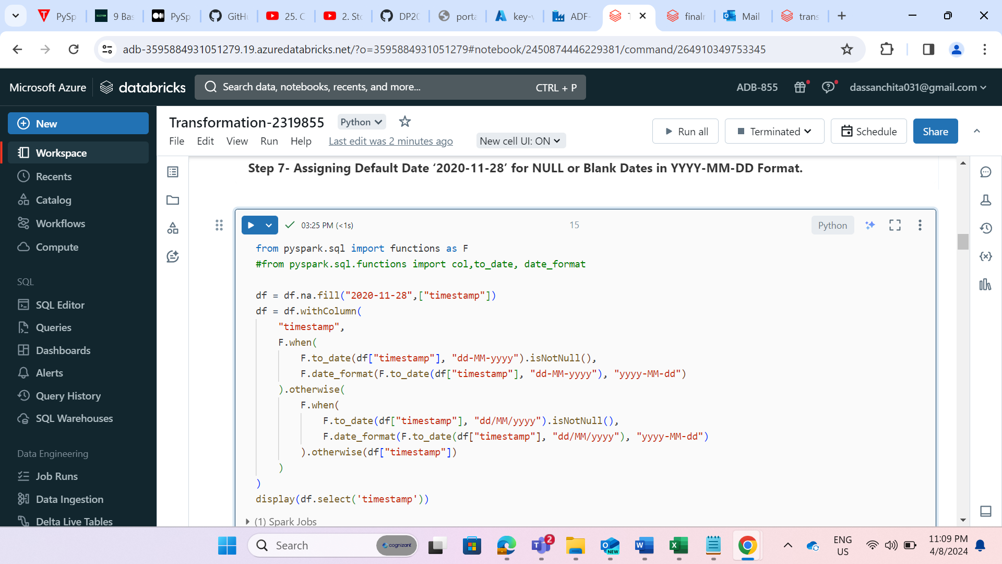

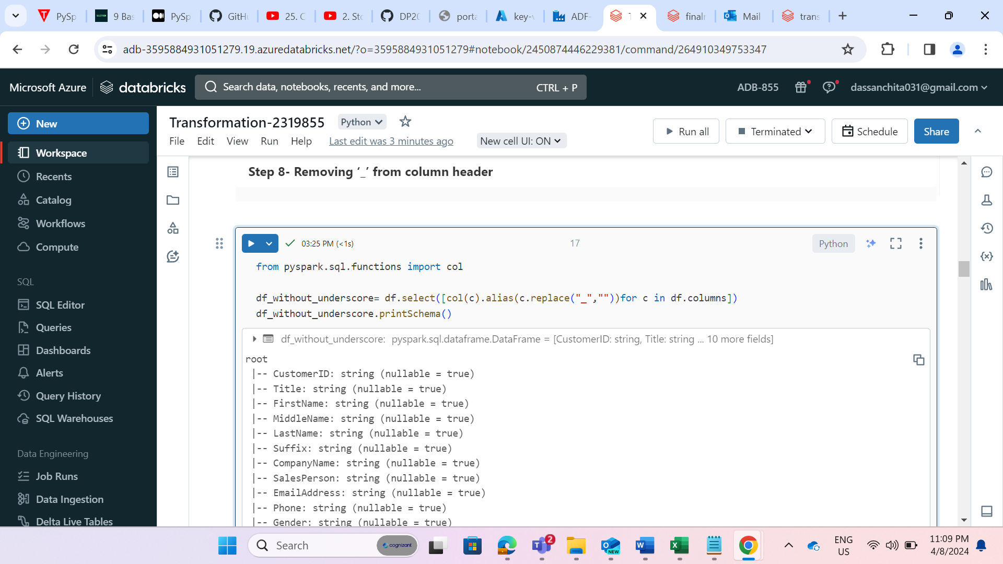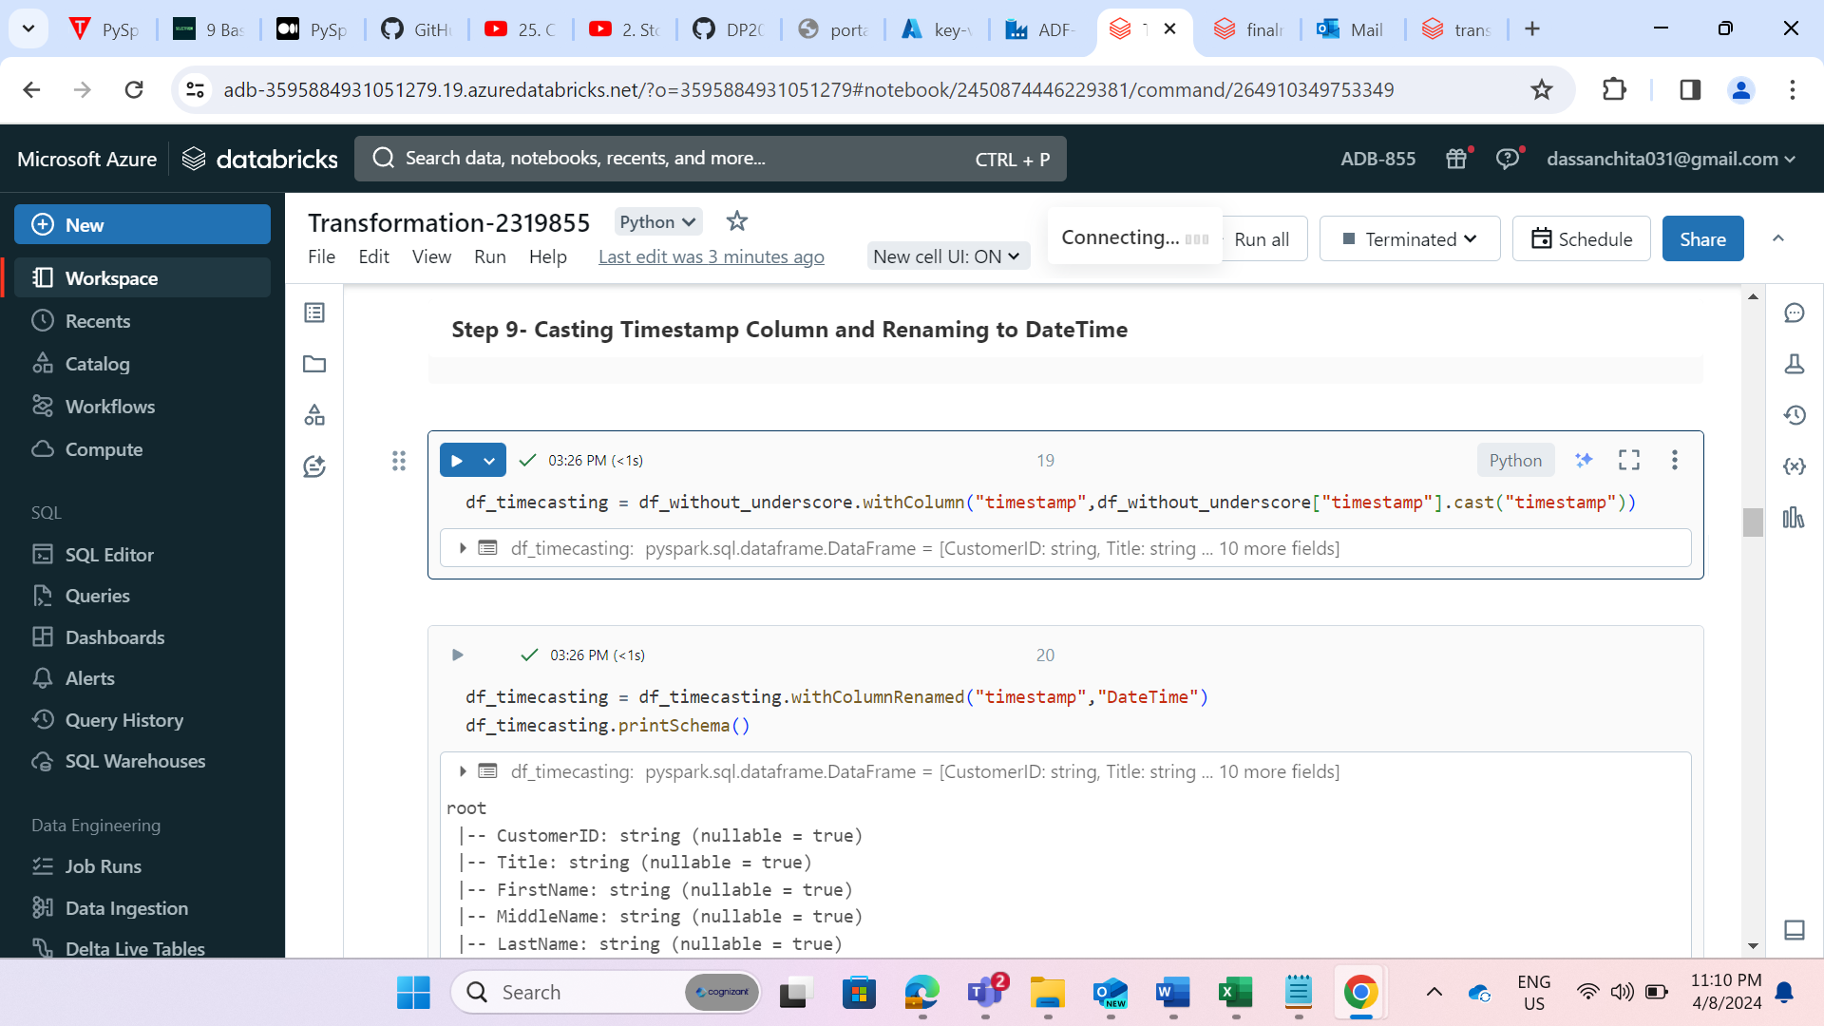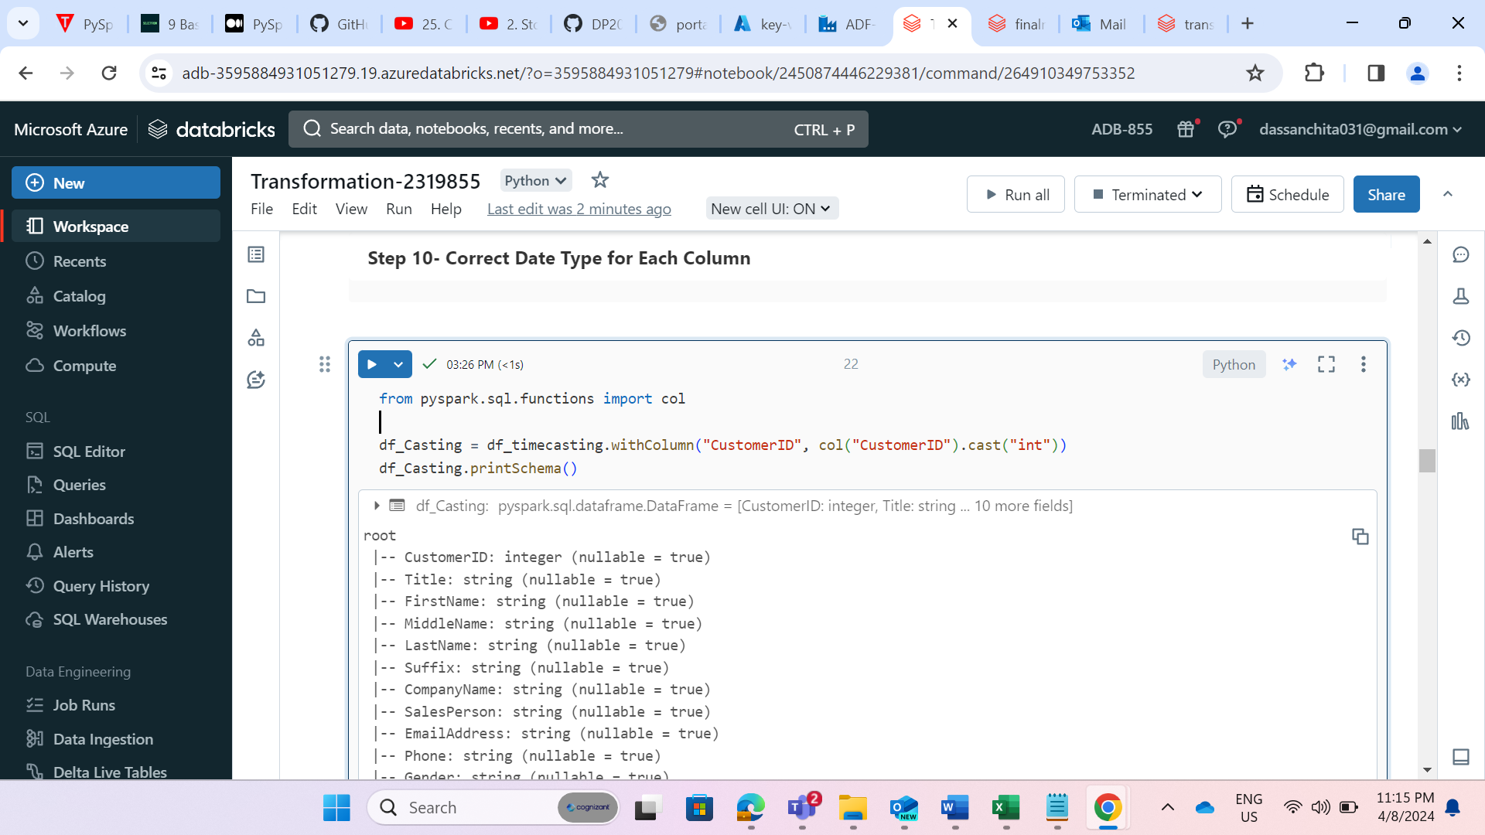

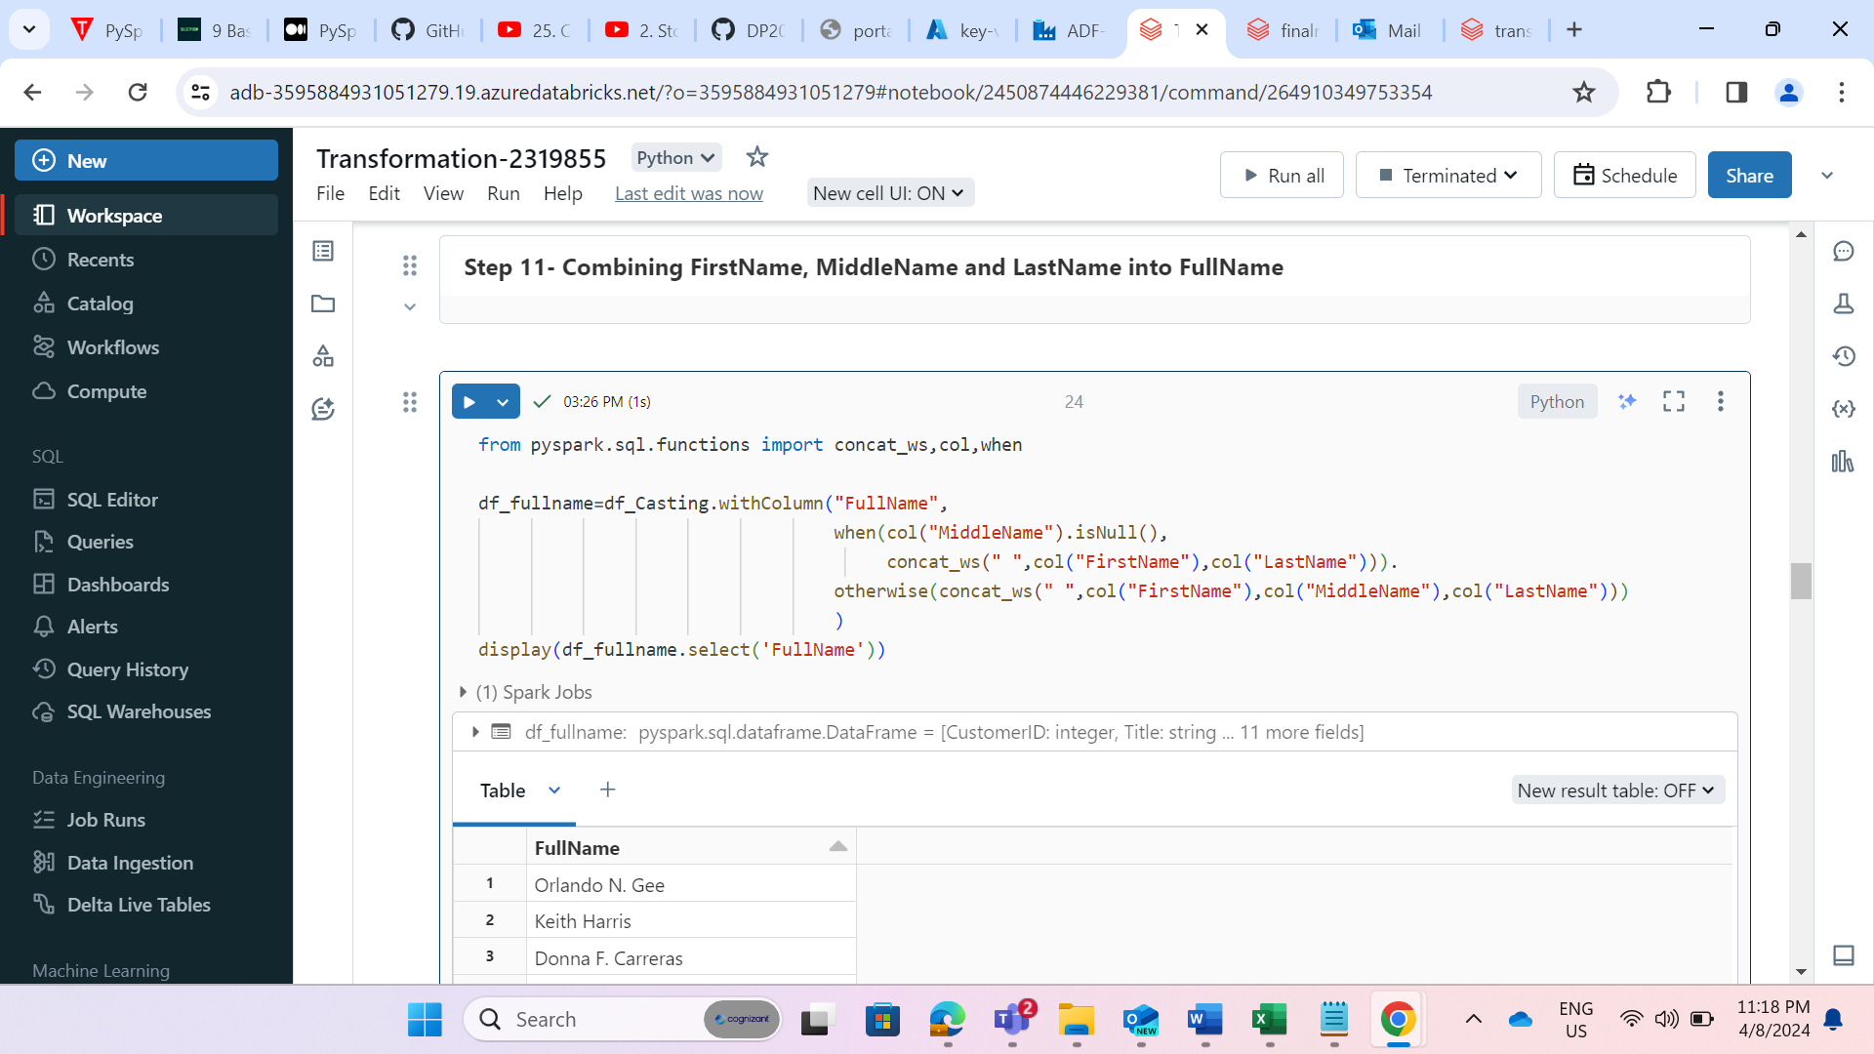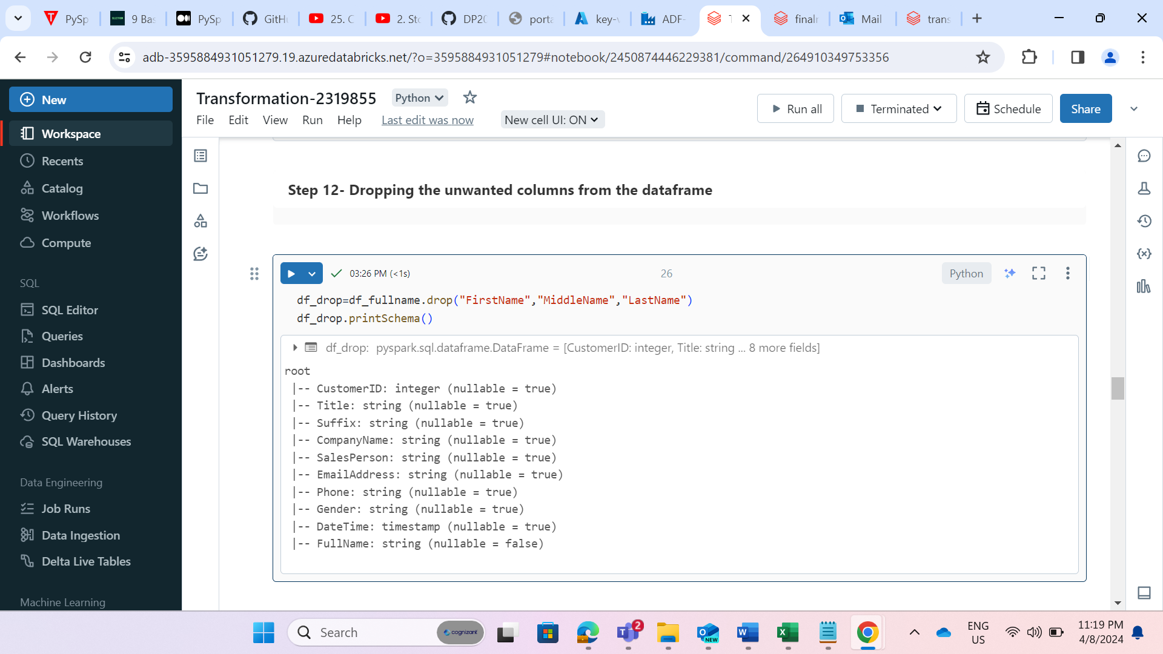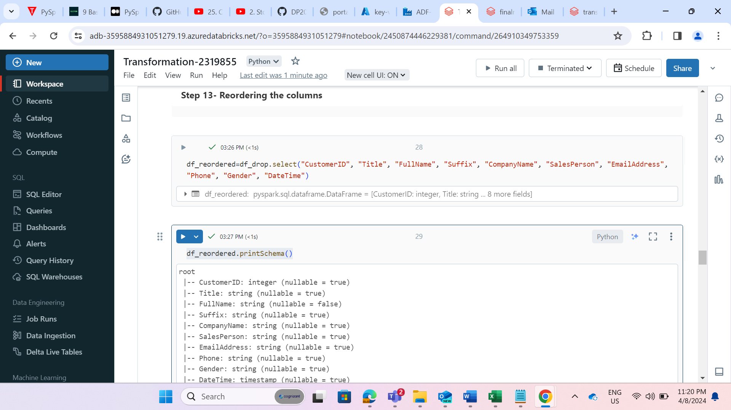

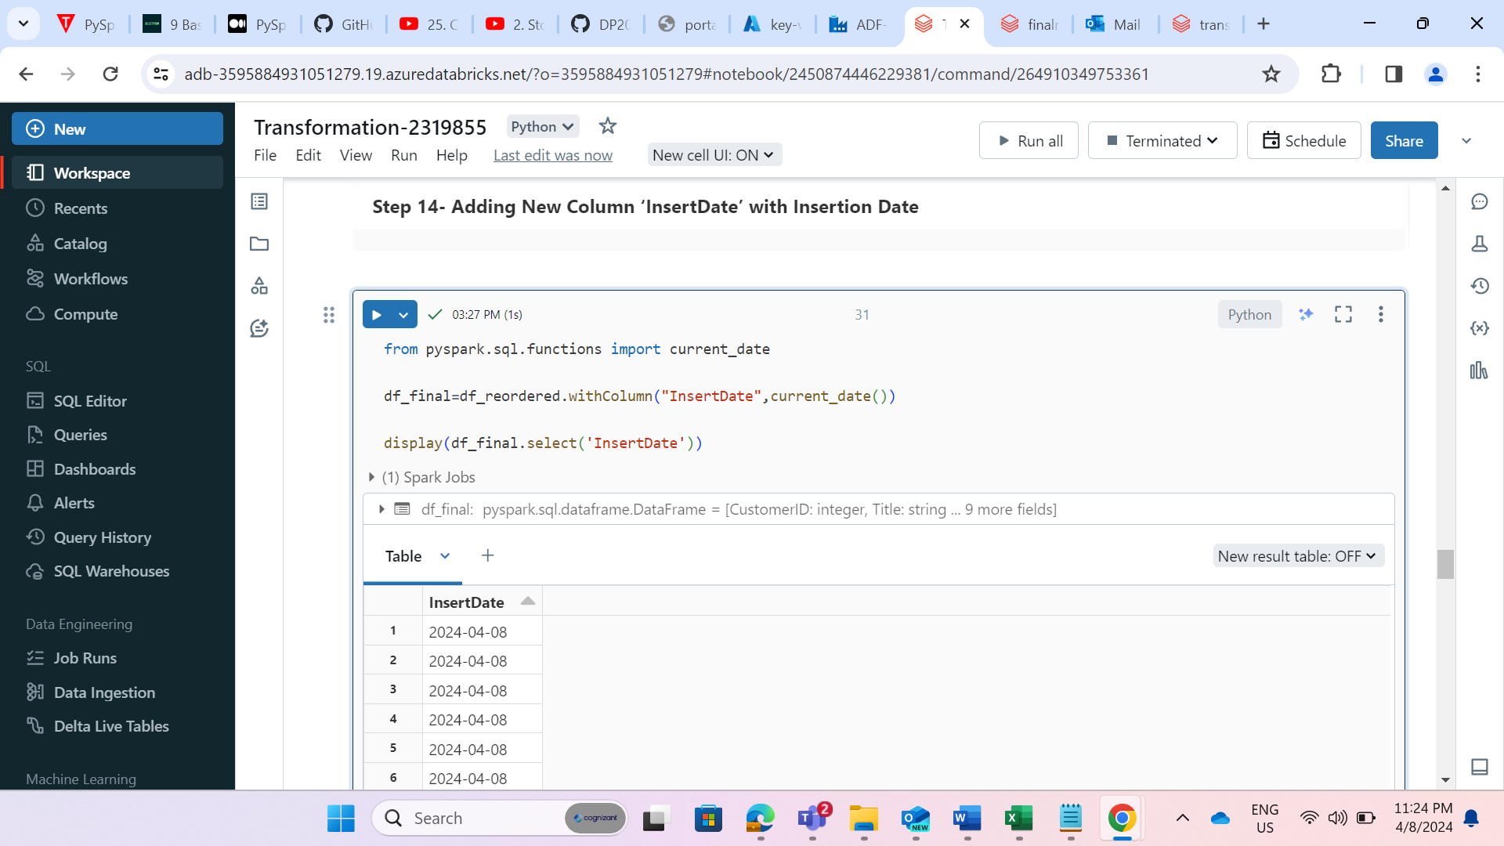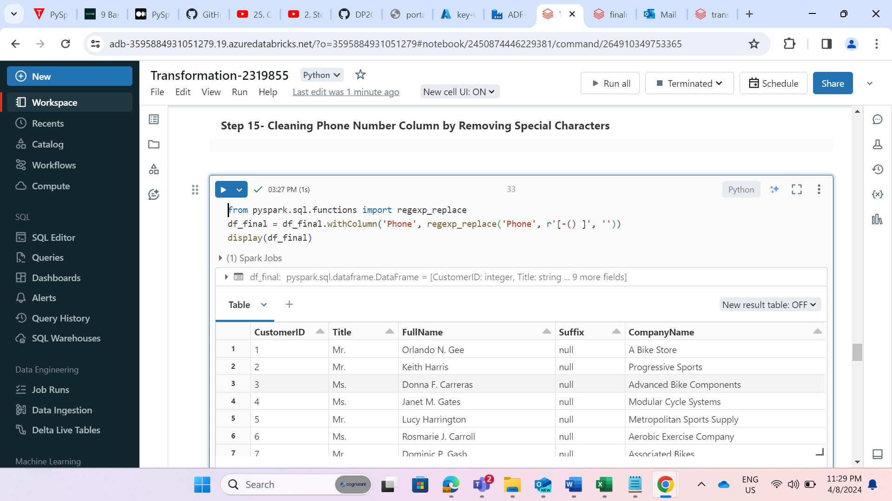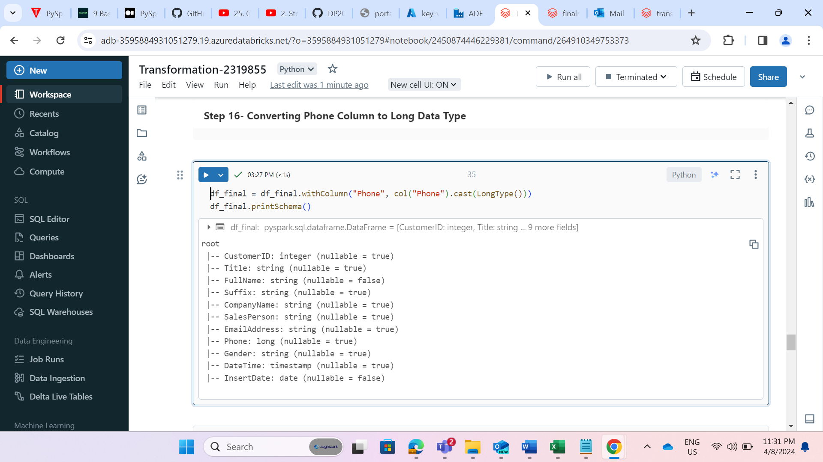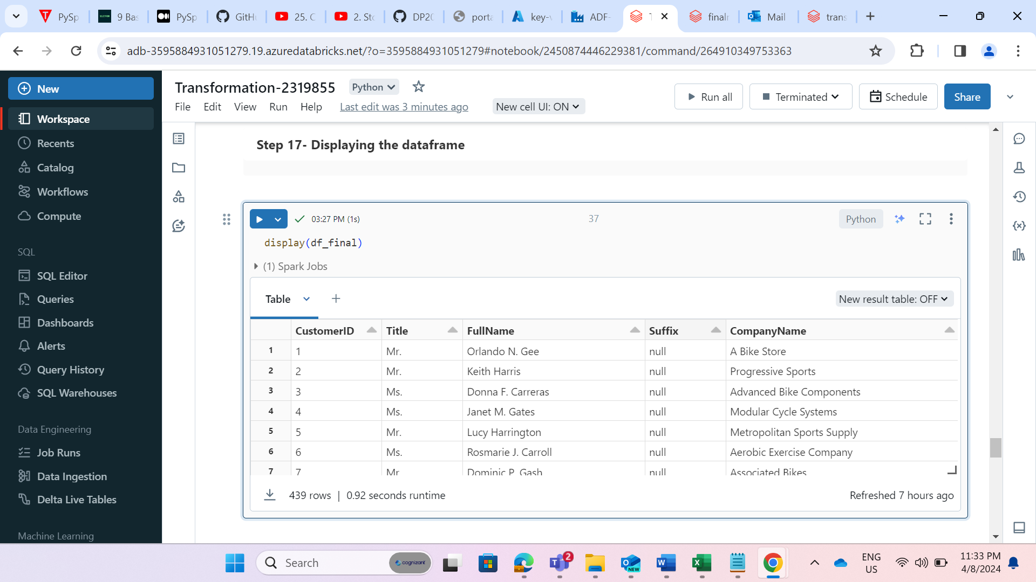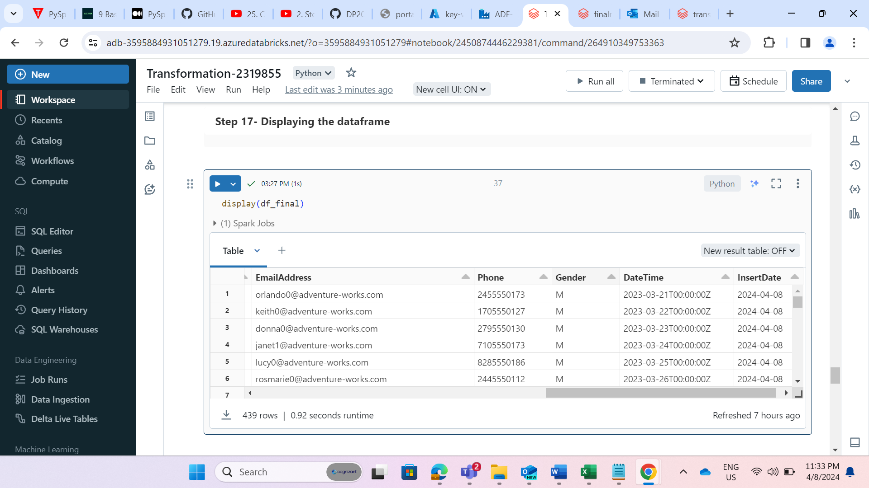 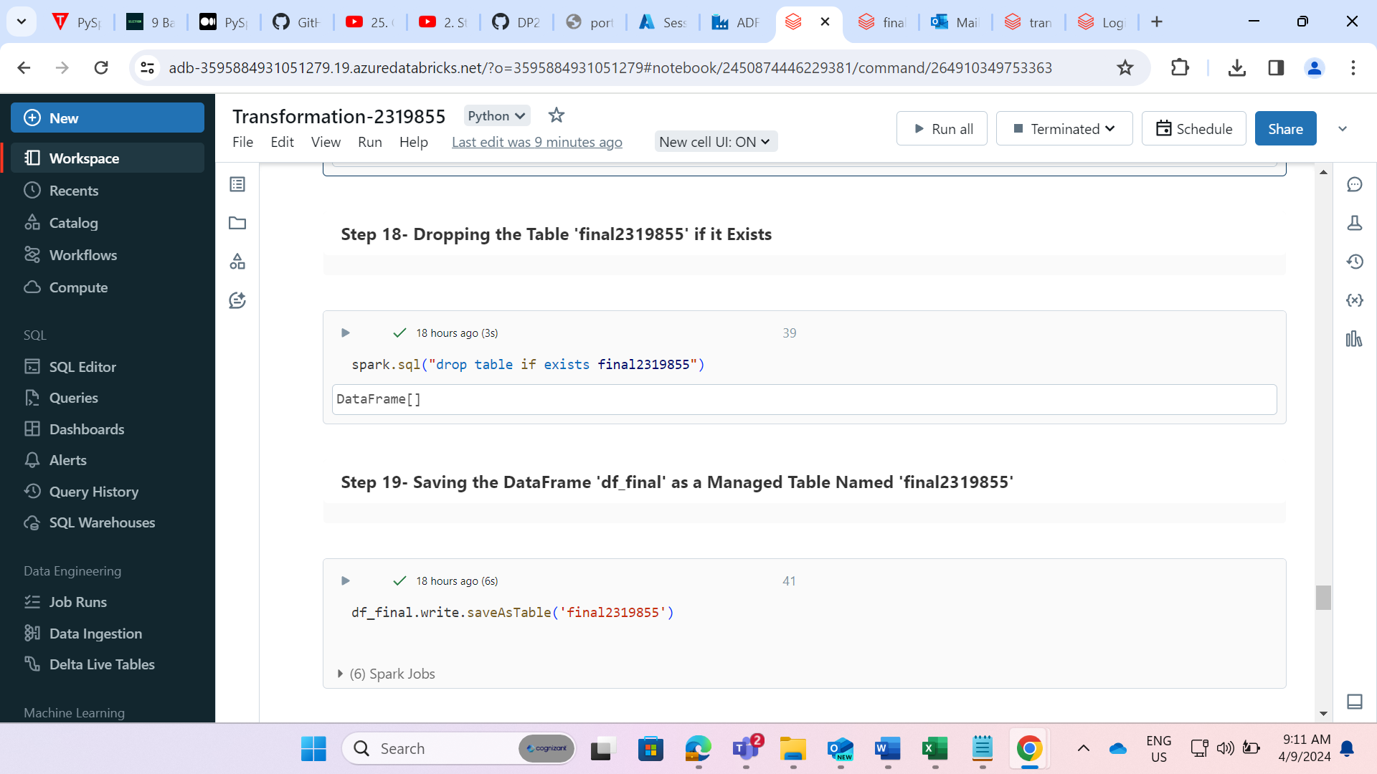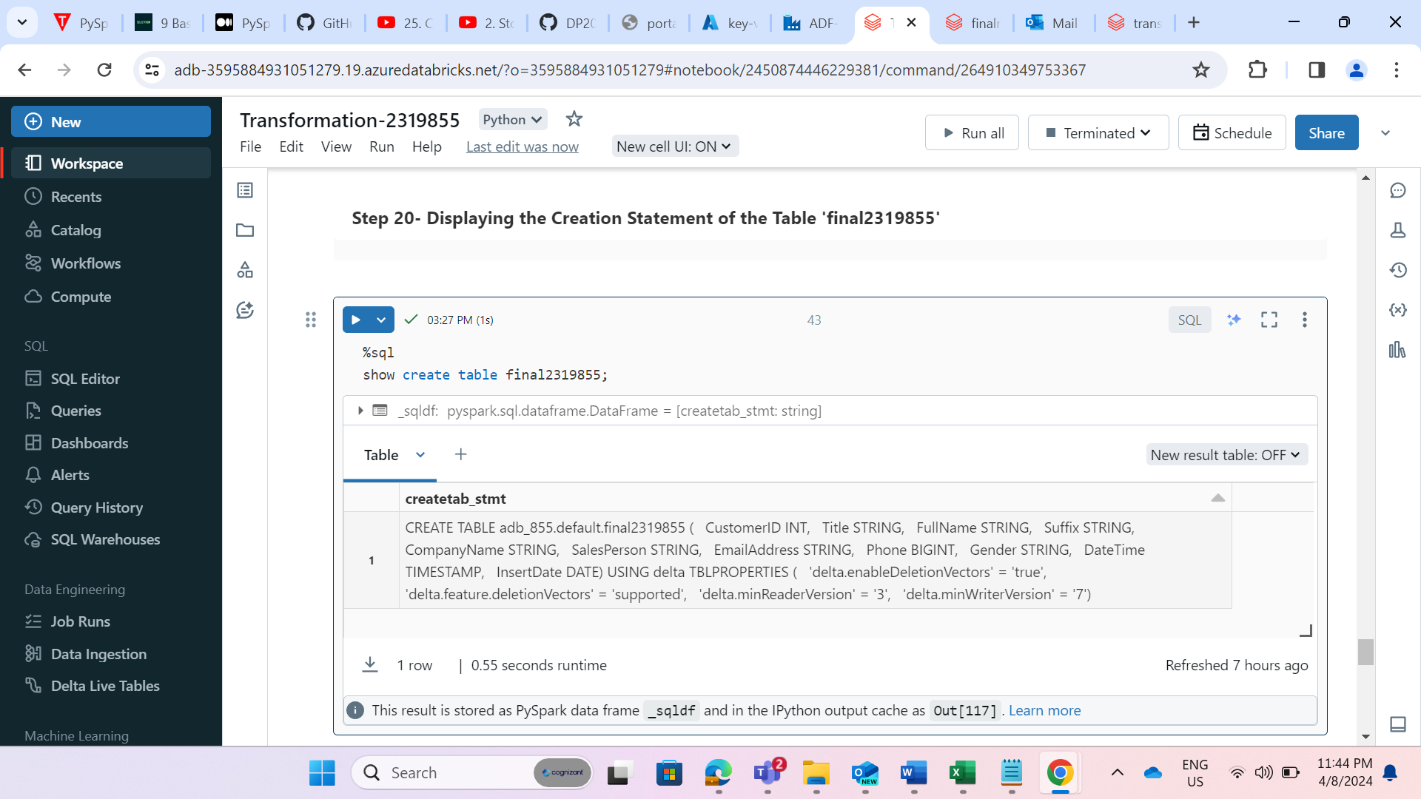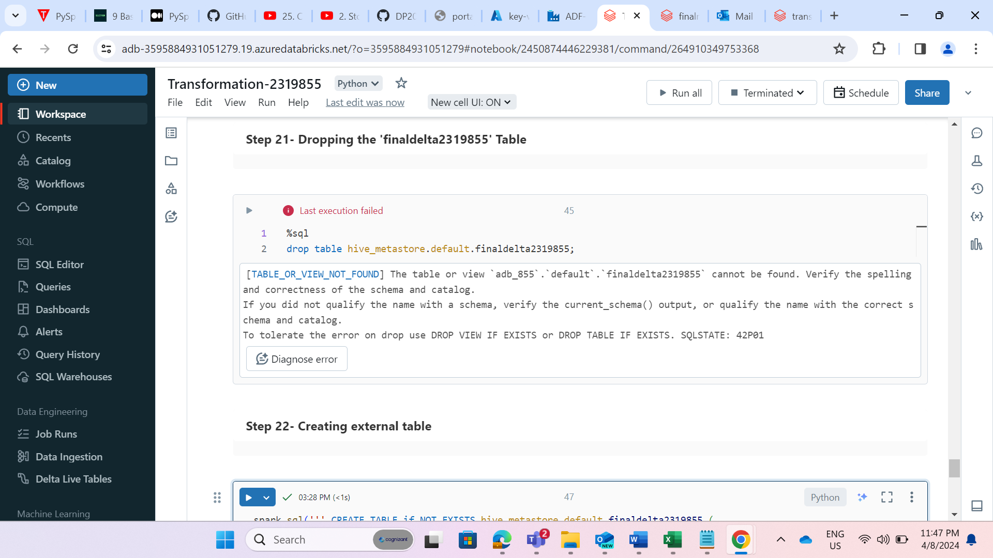 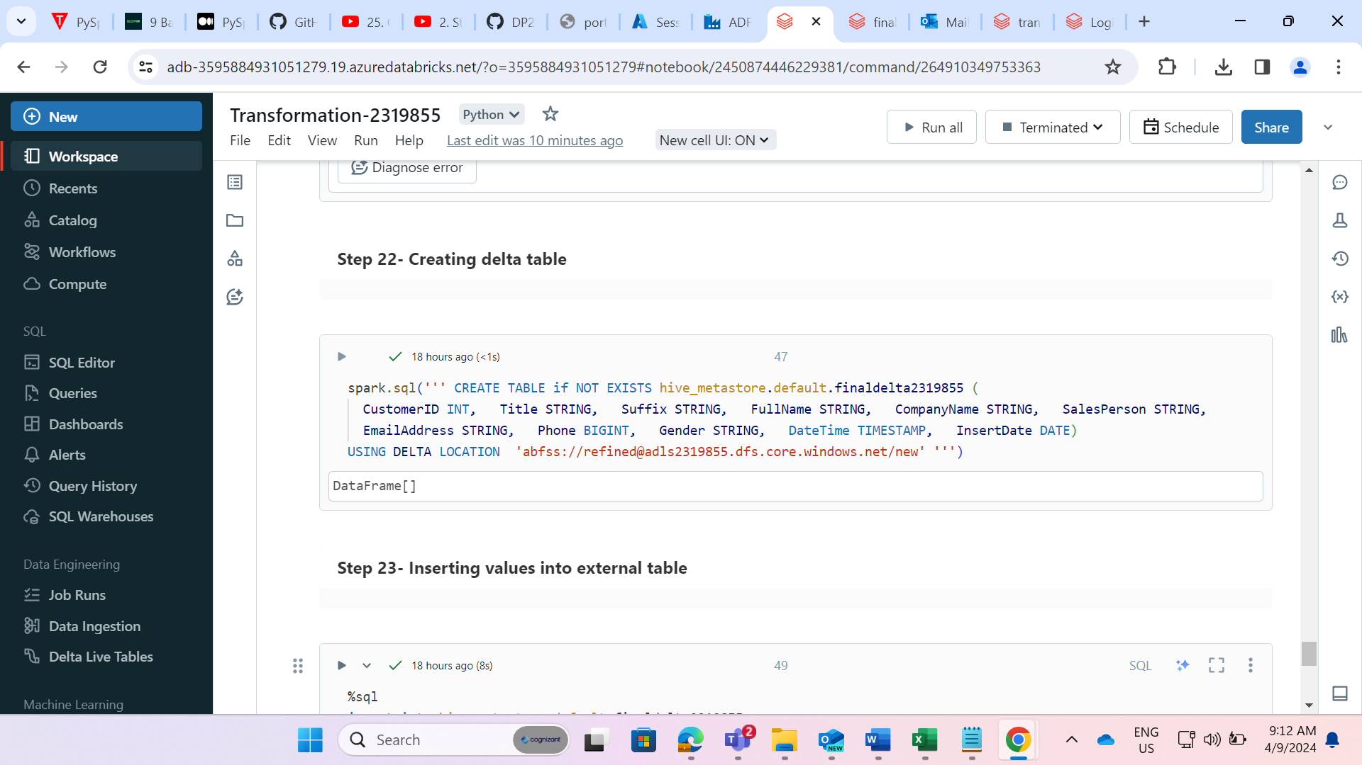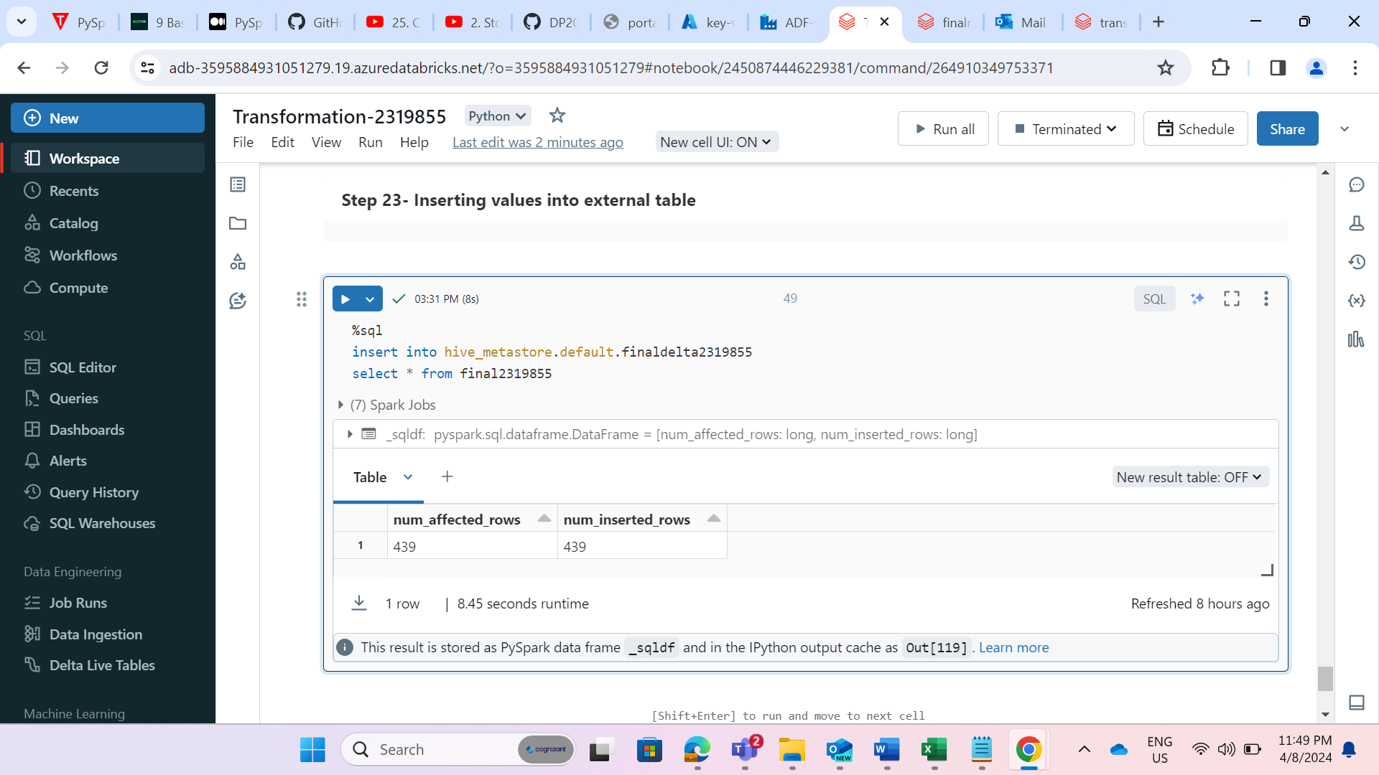

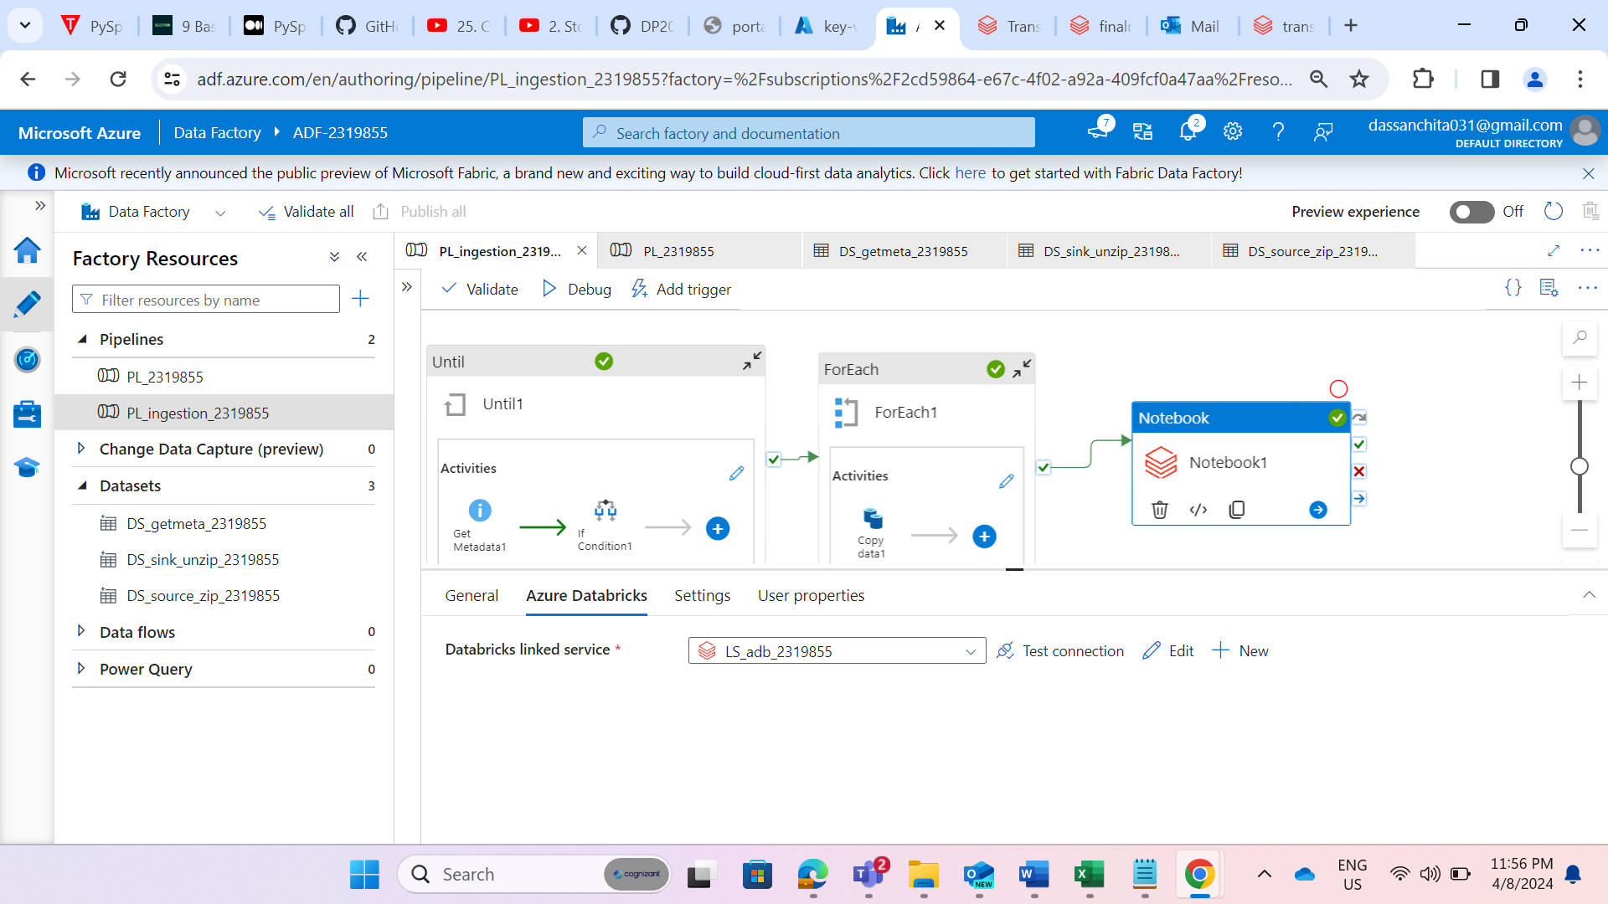

**STEP 26:** Added the notebook activity and output of foreach activity should be given to notebook activity.

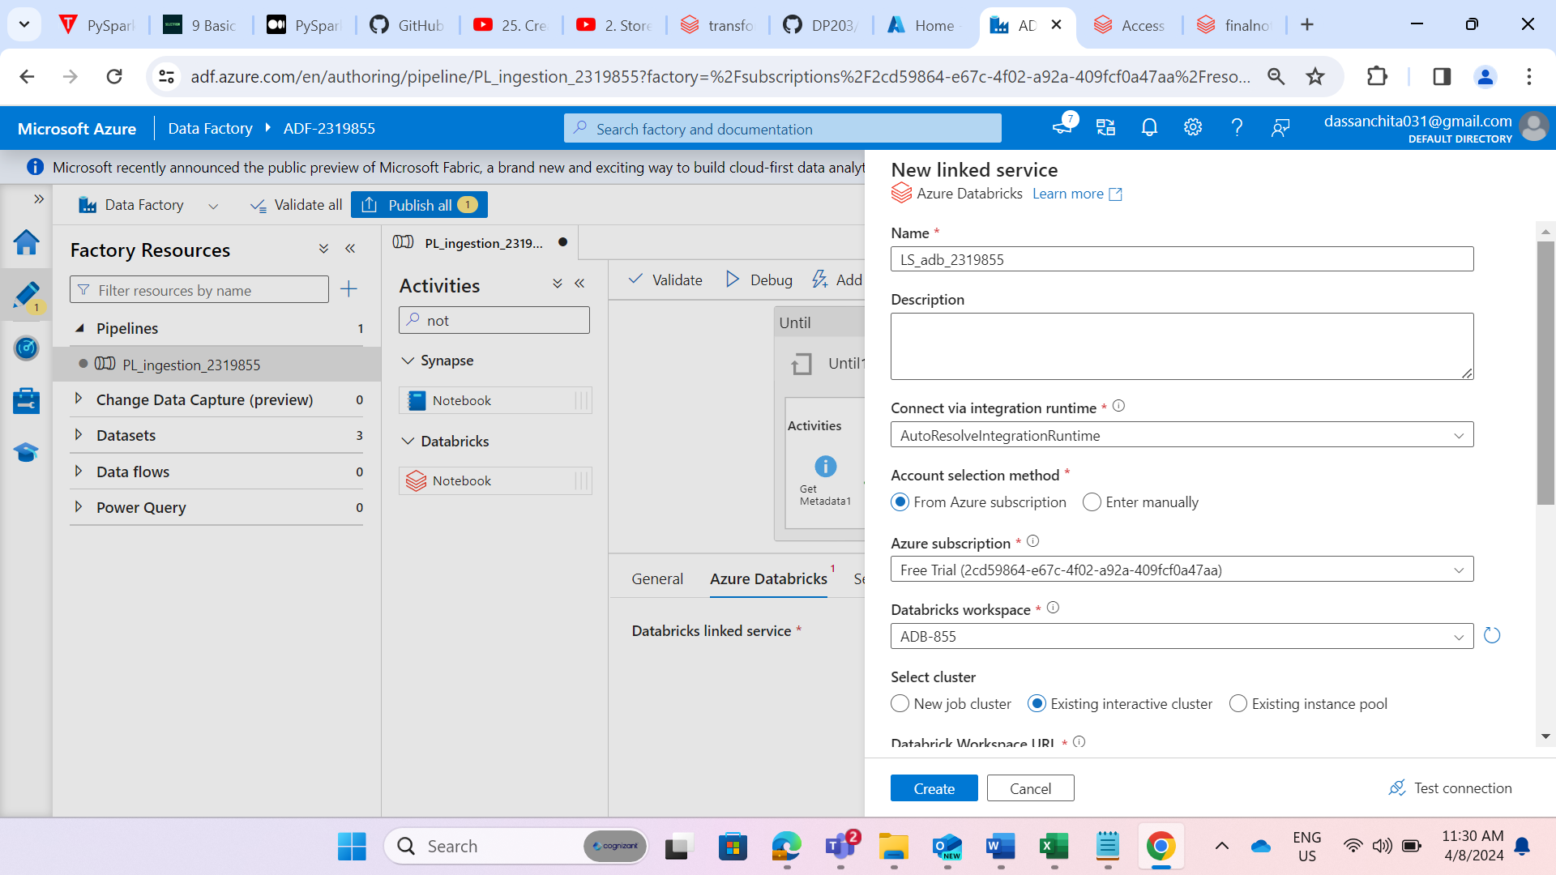**STEP 27:** Created a linked service for linking databricks with datalake.

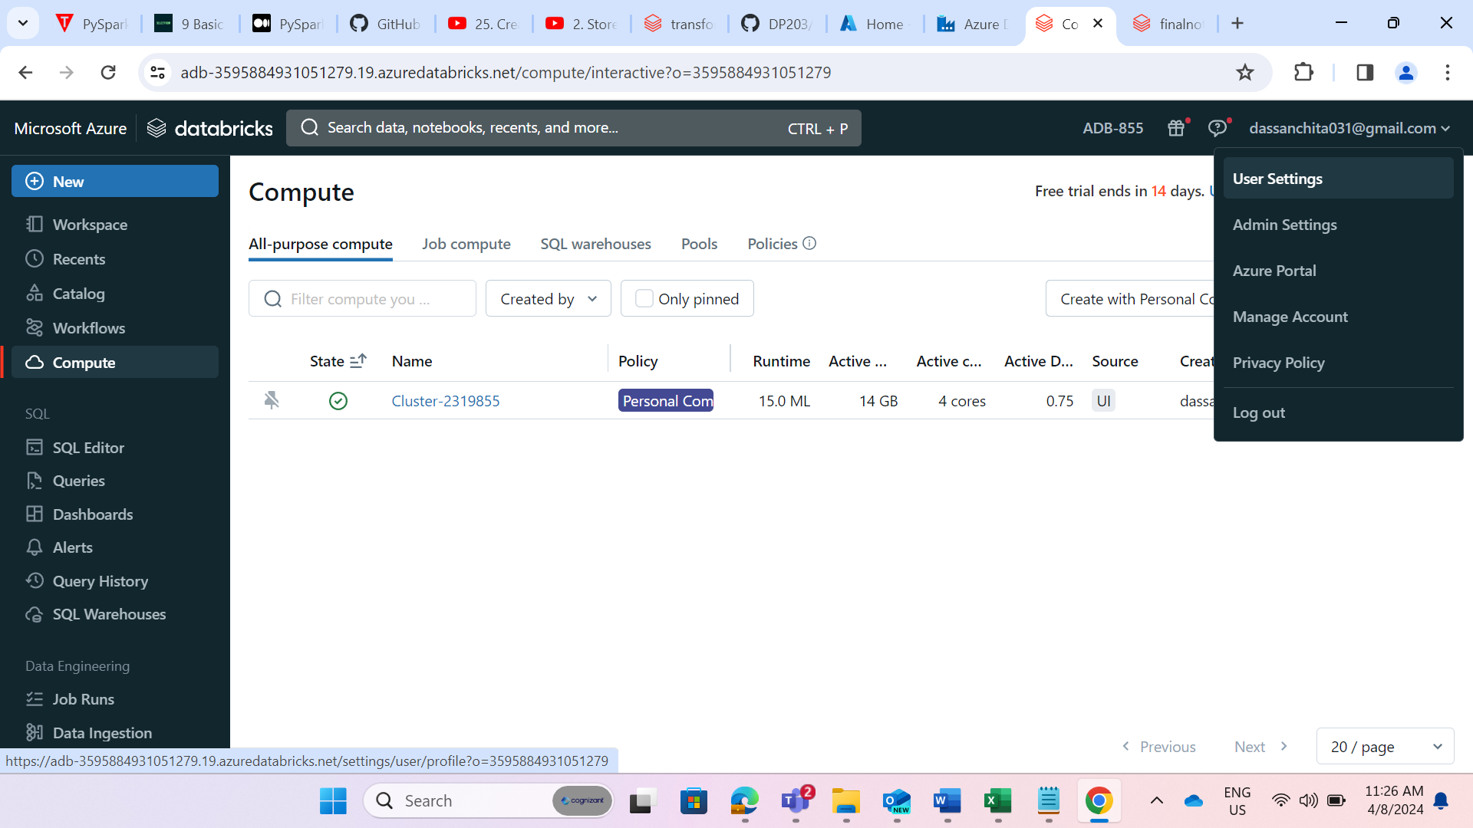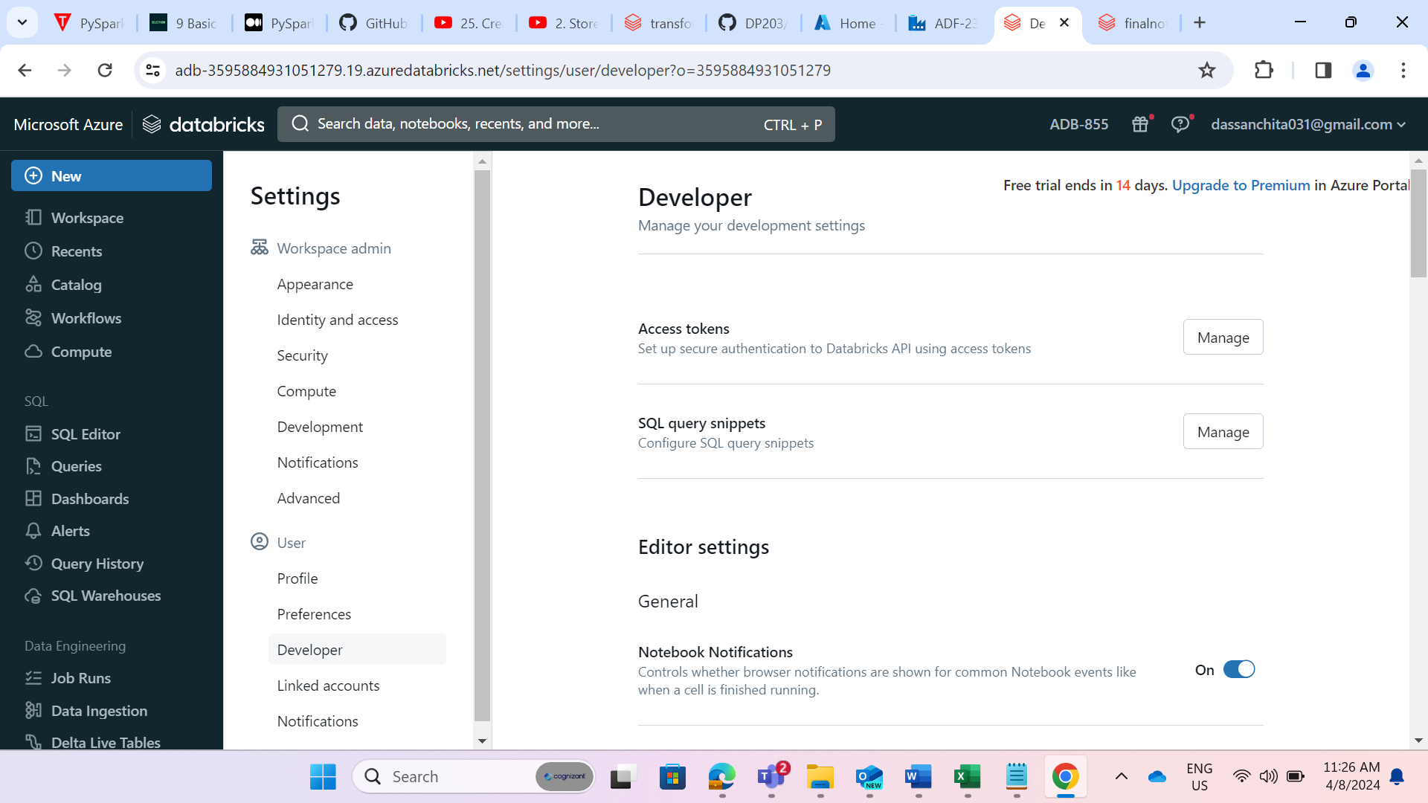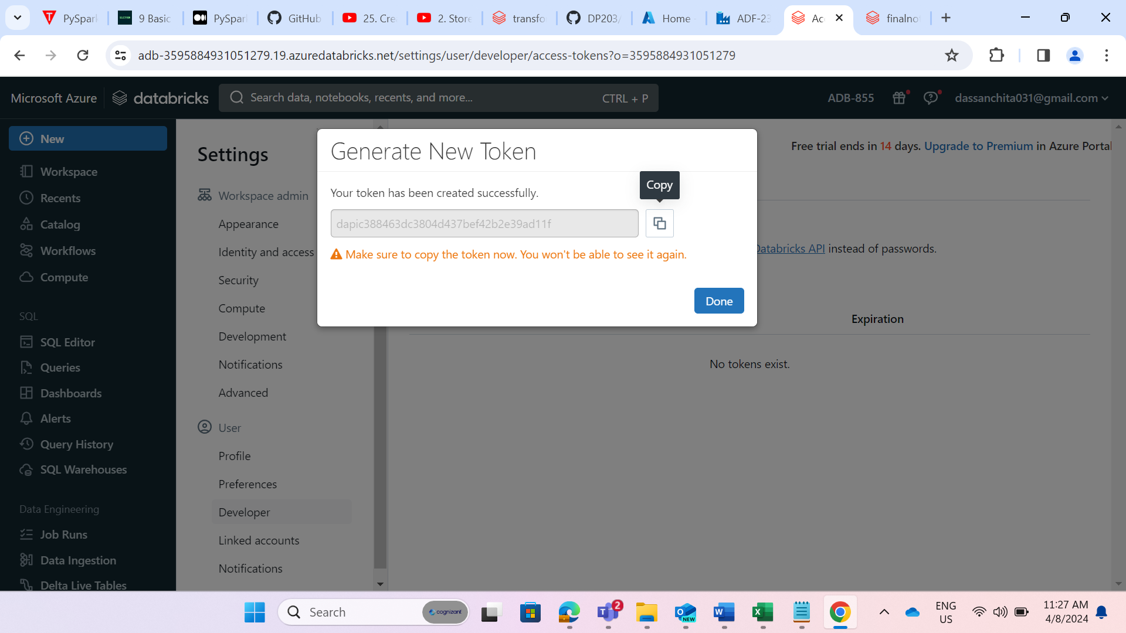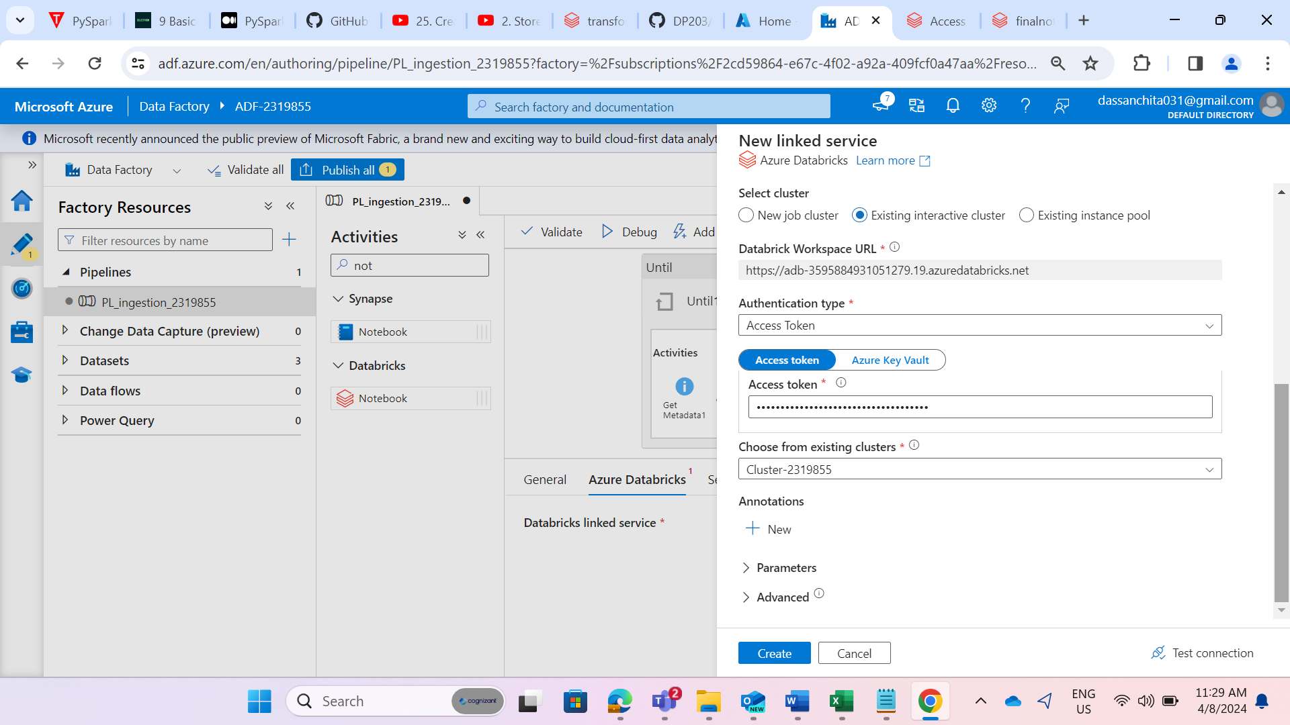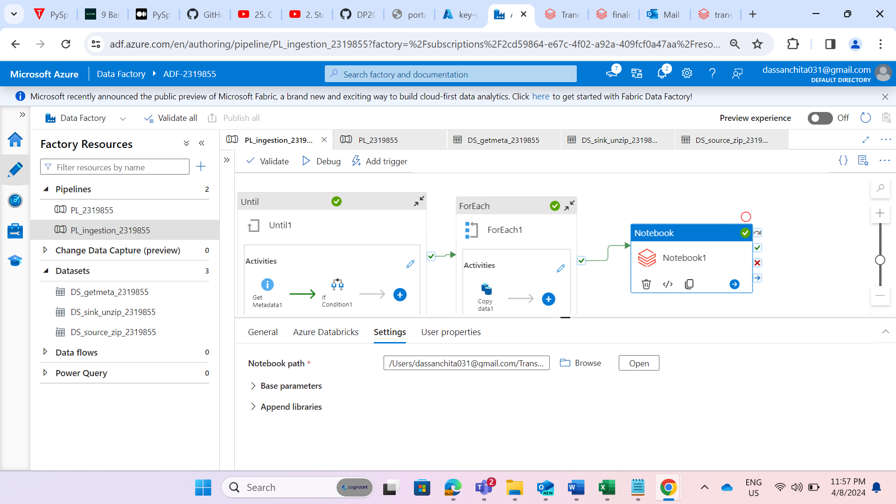

STEP: Browse the path of the notebook.

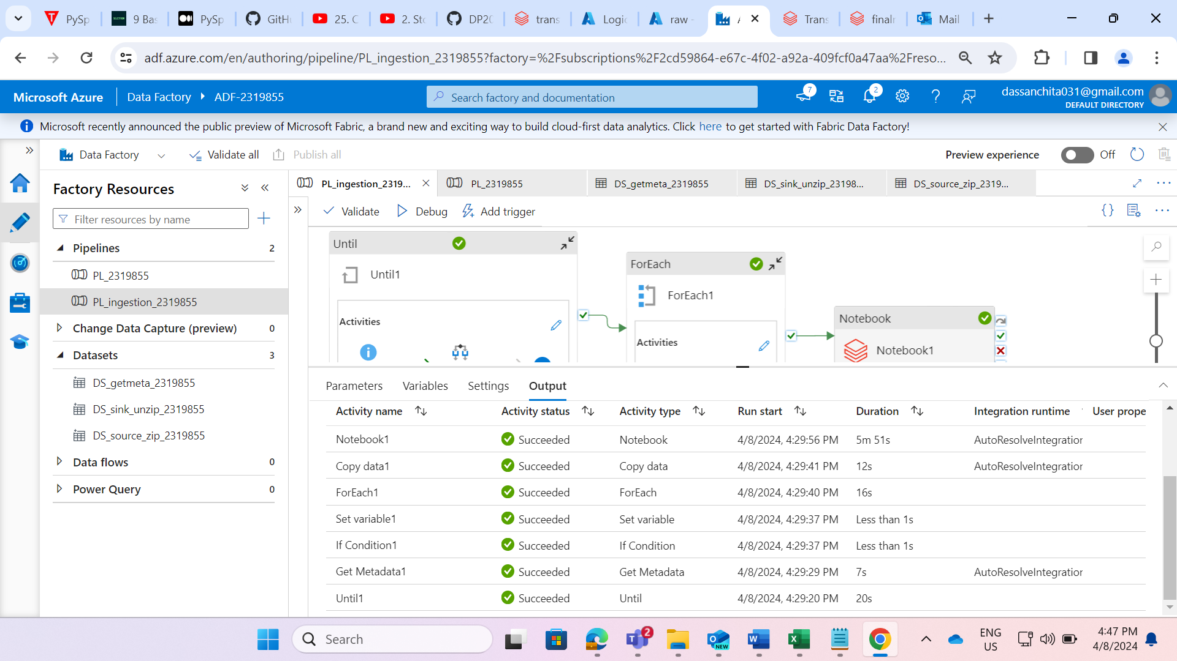

STEP: We have successfully runned the child pipeline

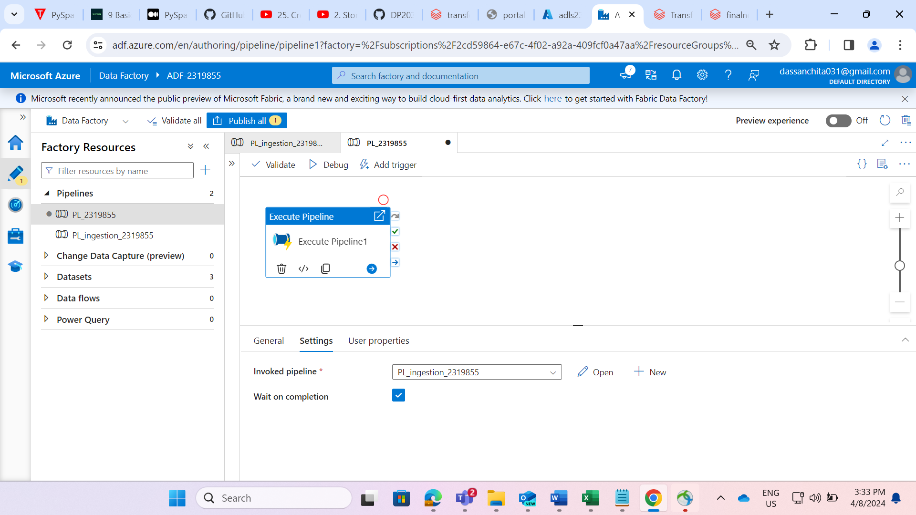

STEP: Created the main pipeline and involve the child pipeline into main pipeline.

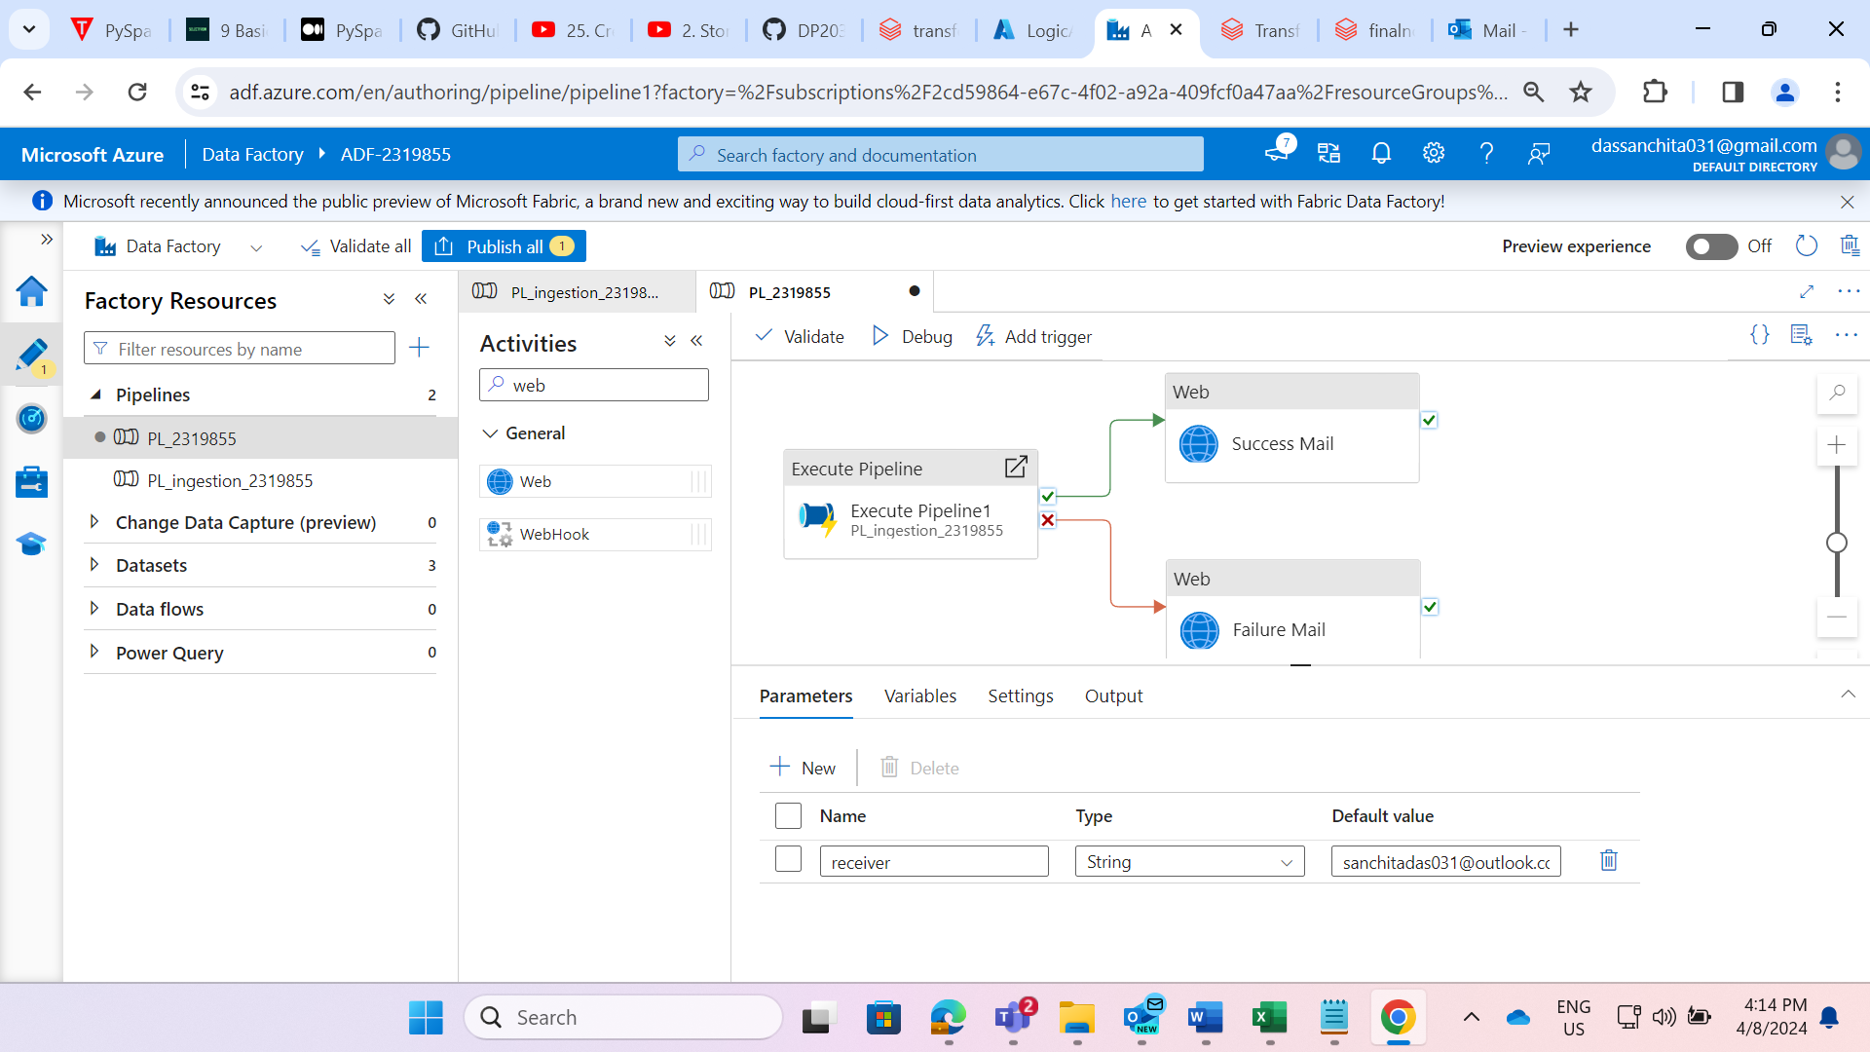

STEP: On success and failure of the child pipeline ,added the web activities to trigger the mail on both success and failure and creating a parameter at a pipeline level and setting the default value as email.

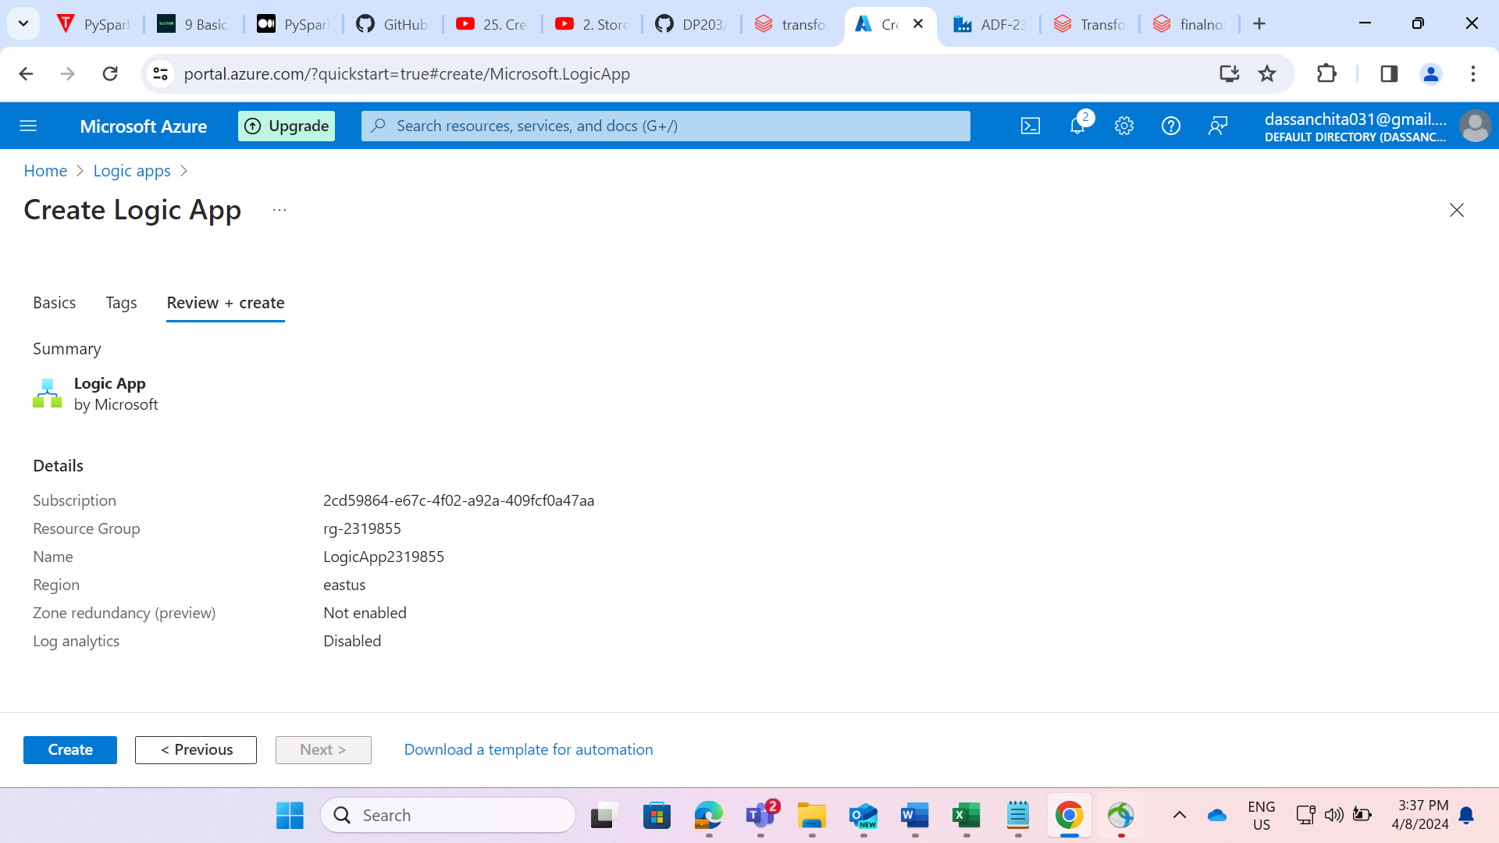

STEP: Created the logic app named as “LogicApp2319855”

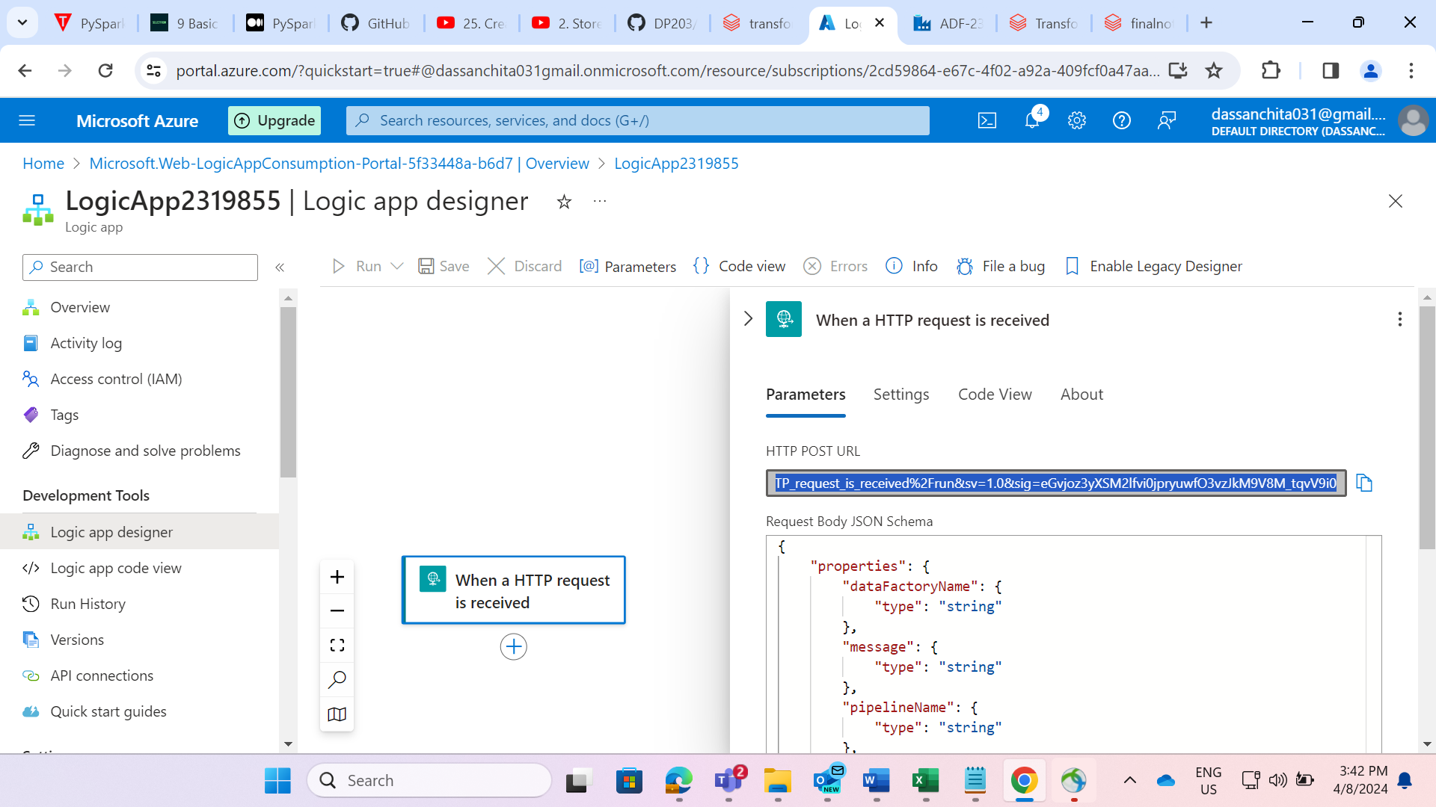

STEP: Go to logic app designer and click on trigger.

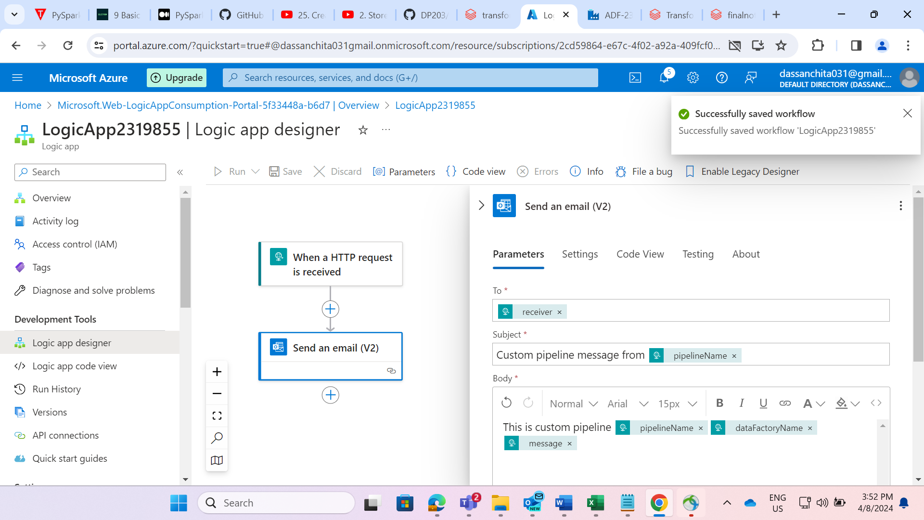STEP: Give the http request and when request is received, trigger the mail.

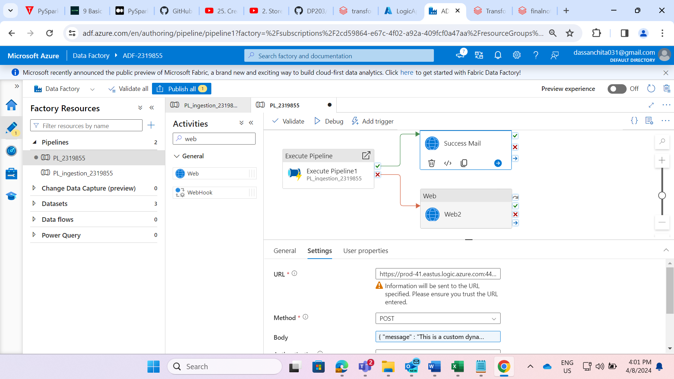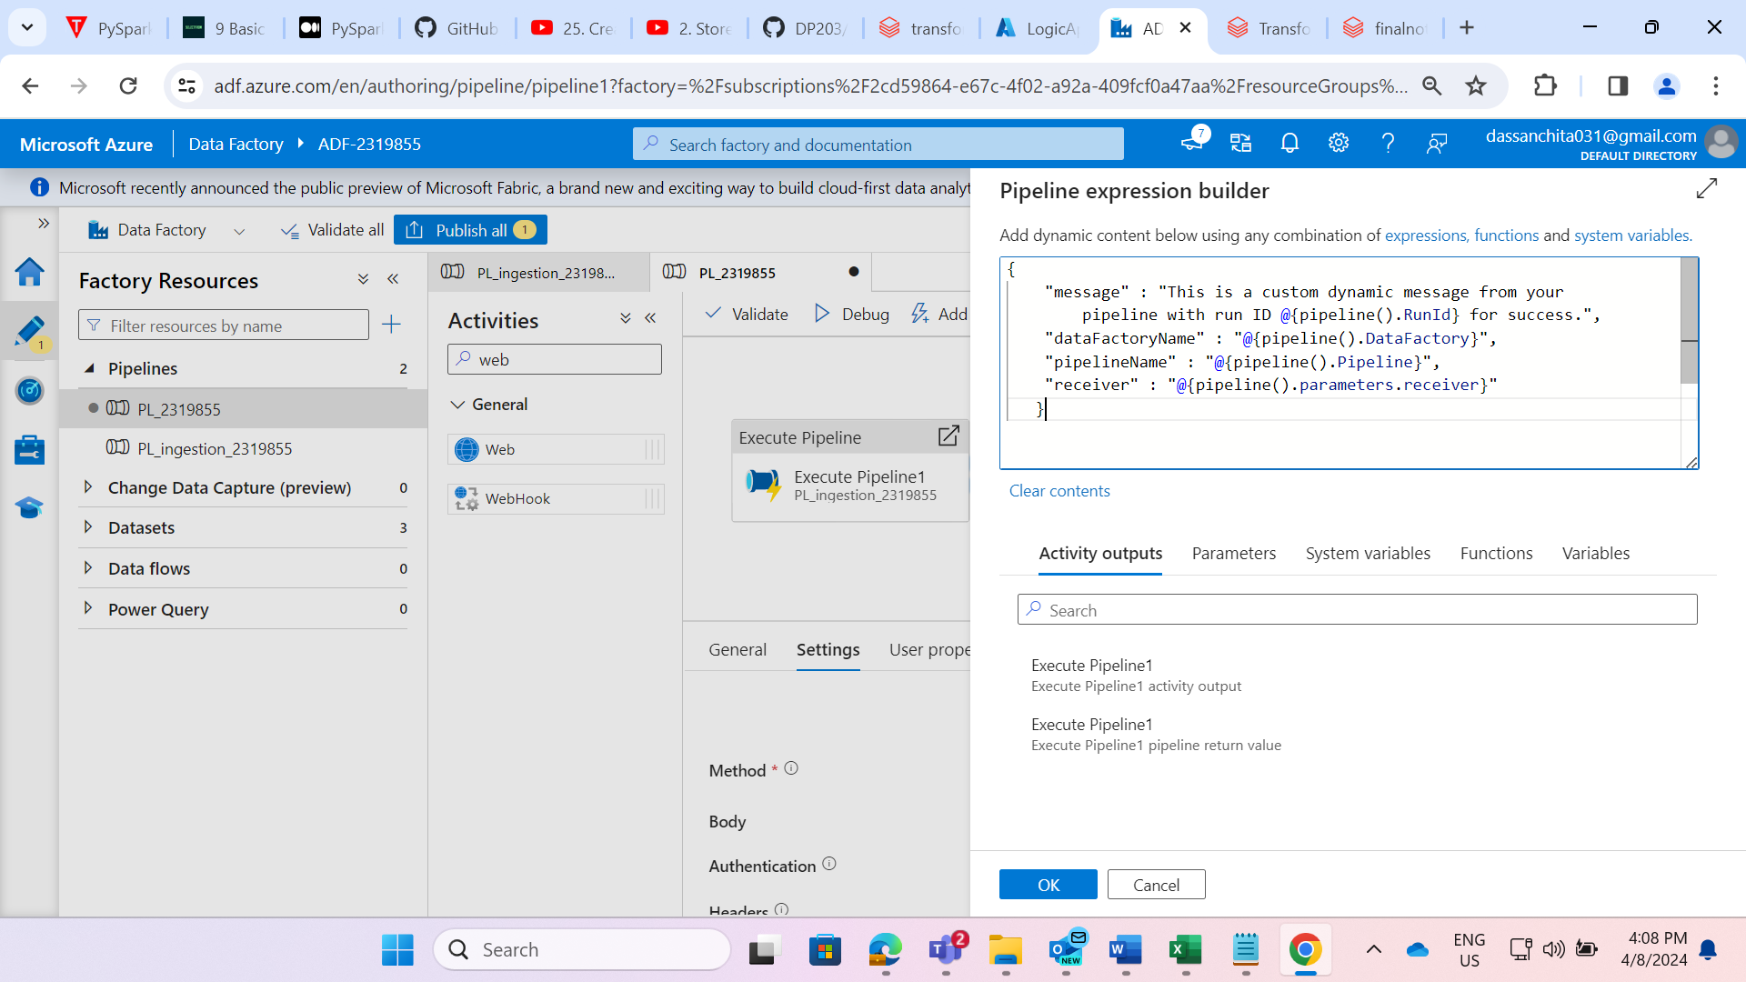

STEP: Go to web activity on success, give the url of http request that we have copied in the logic app designer.

* Select the method as POST.
* In the body, give the message that we should receive on success of pipeline.

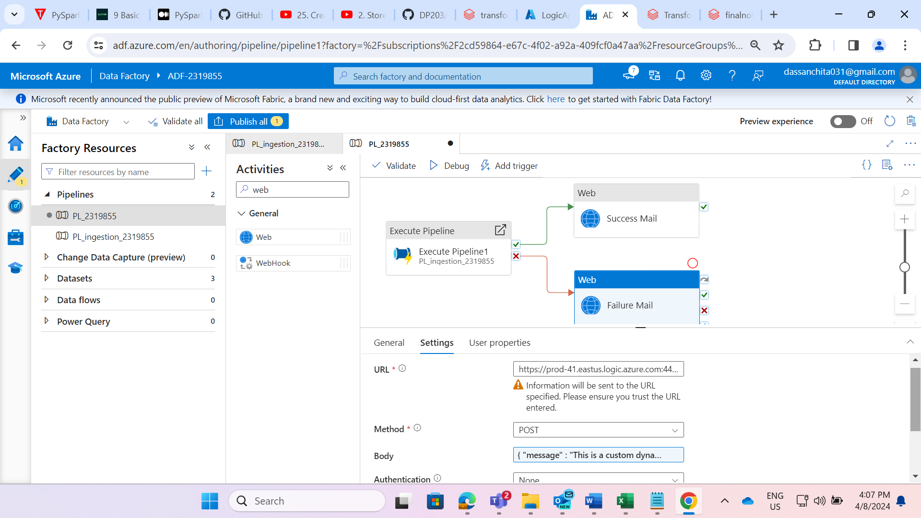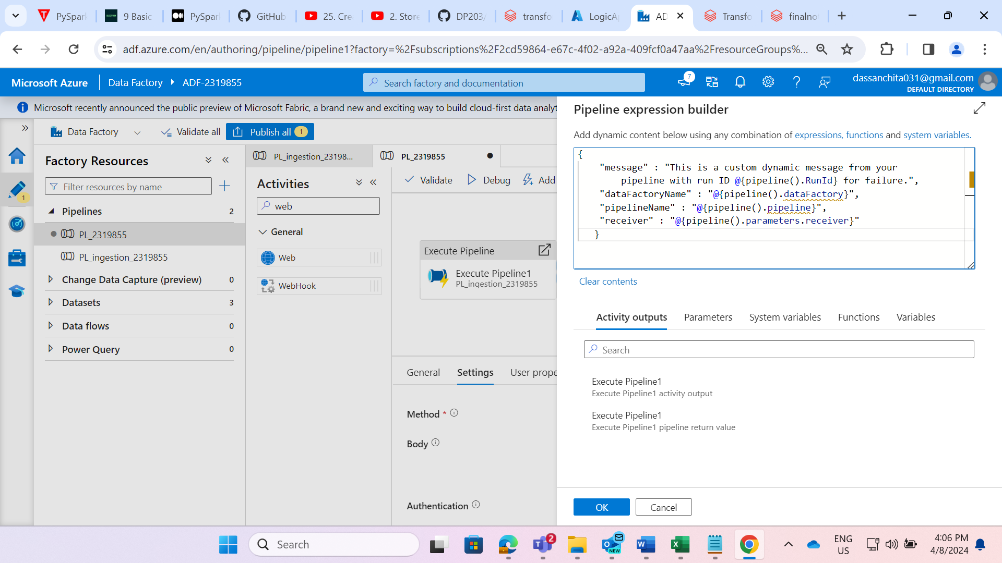

STEP: Go to web activity on failure, give the url of http request that we copied in the logic app designer.

* Select the method as POST.
* In the body, give the message that we should receive on failure of pipeline.

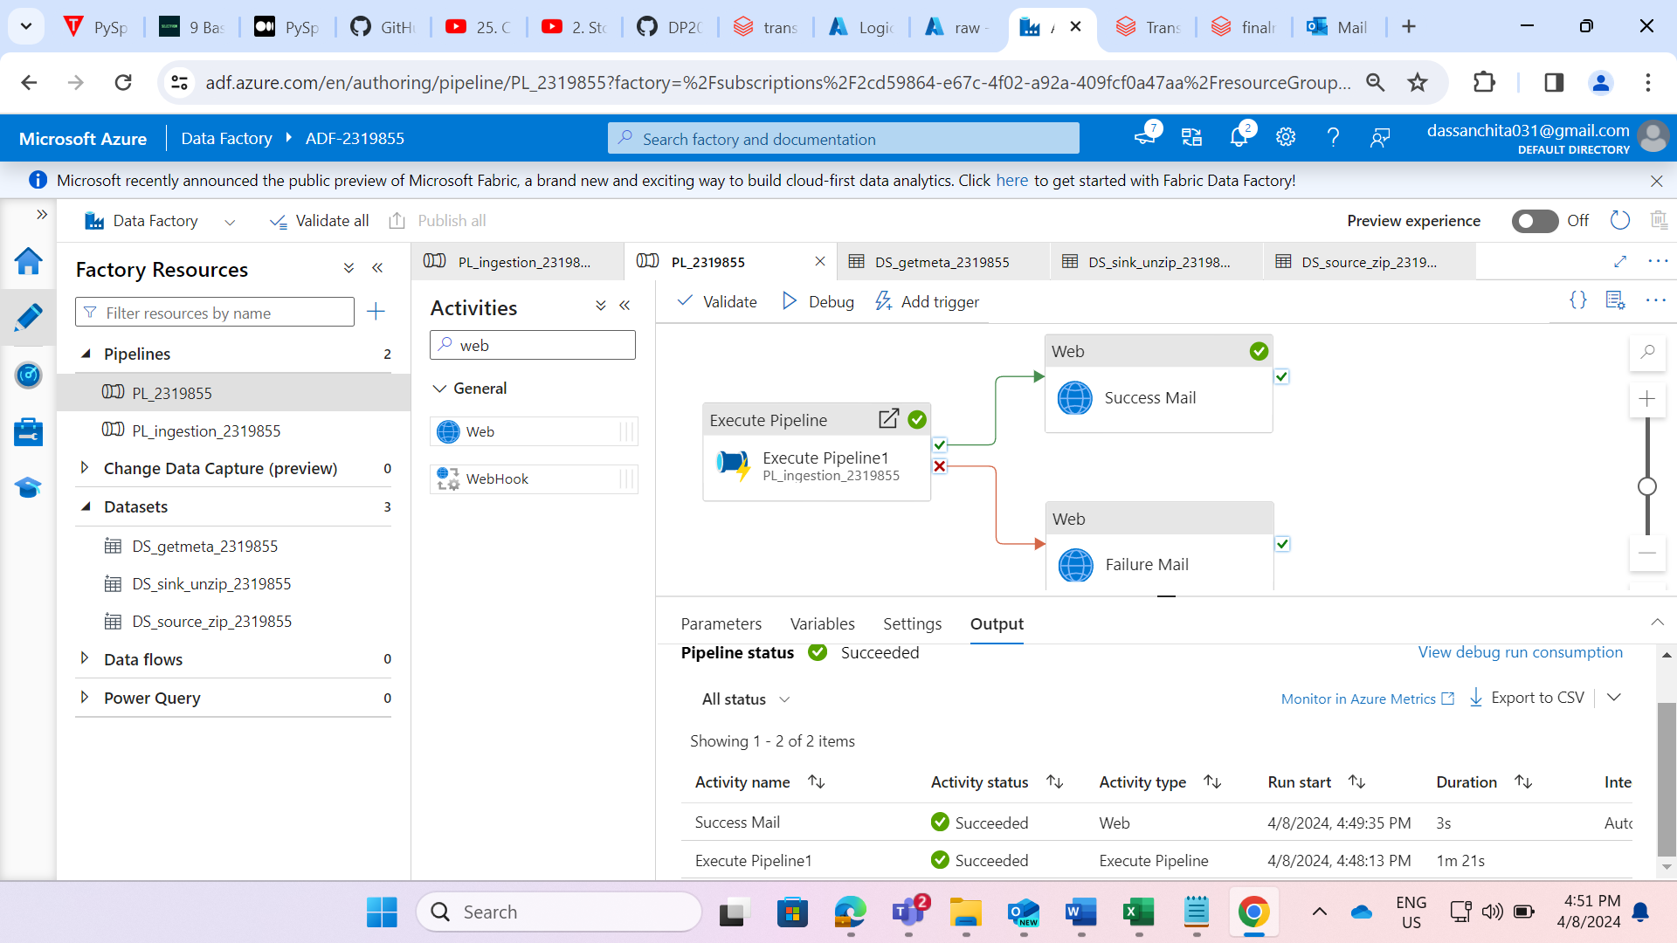

STEP: Now, run the main pipeline.

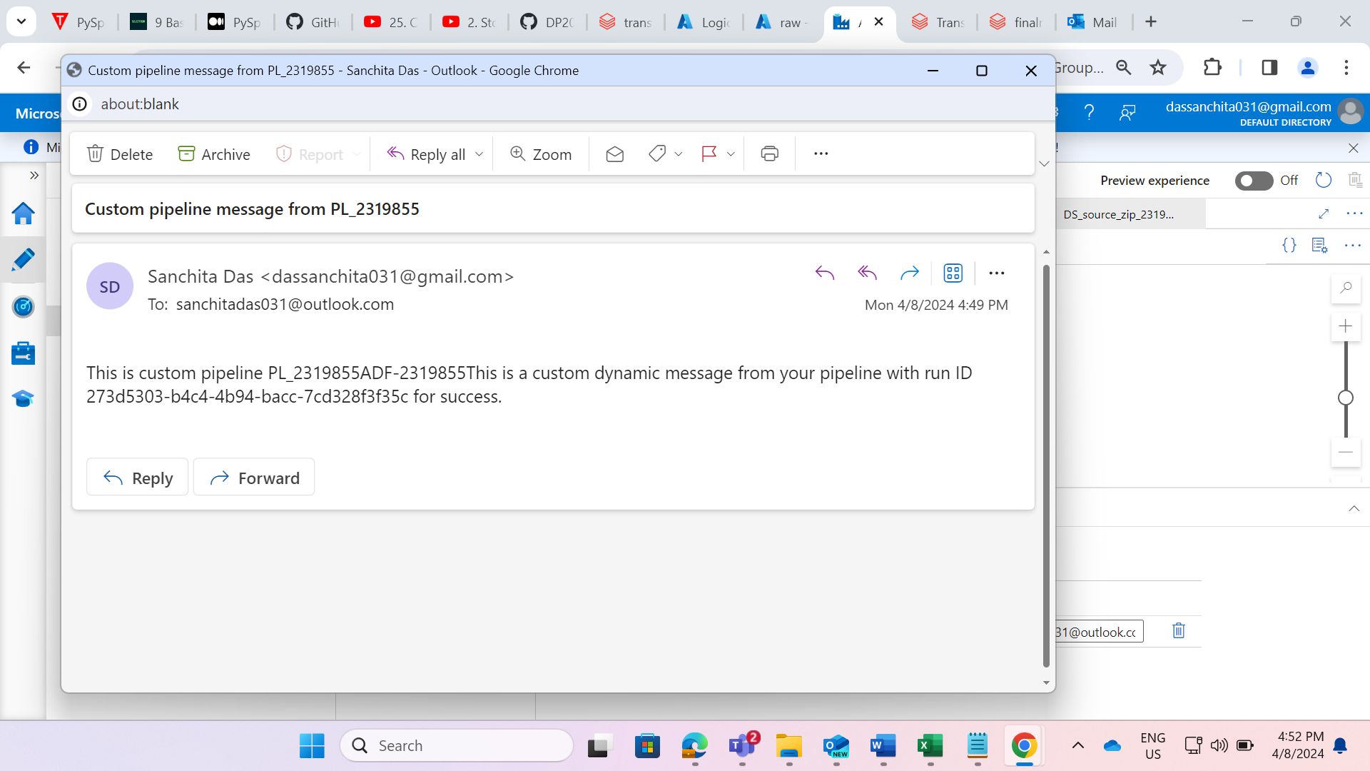STEP: On success or failure of pipeline, we will receive the mail.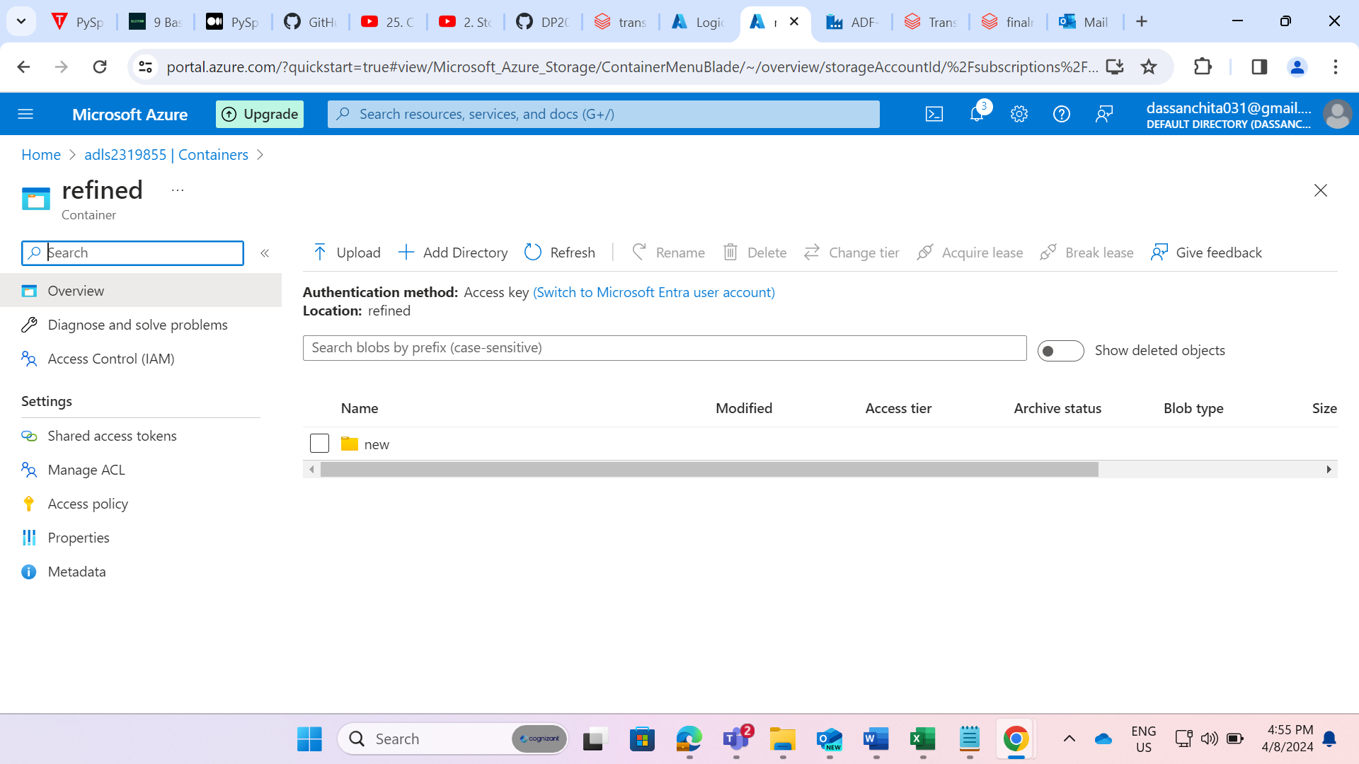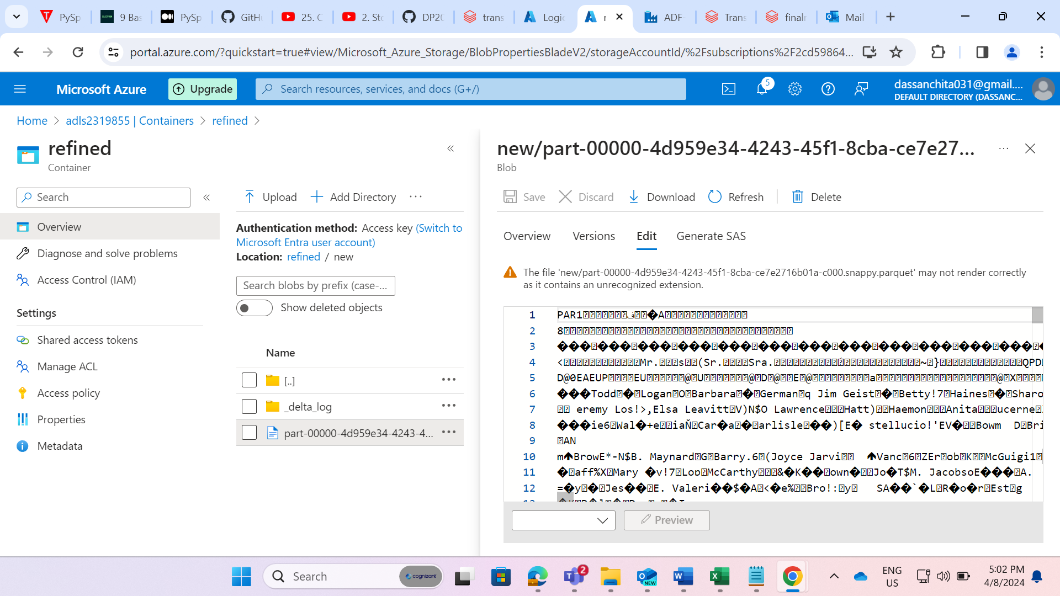

STEP: Now, we have successfully got the parquet file in the refined container in the datalake.